NAJDA
NETWORK FOR AI-POWERED JOINT DISPATCH AND ASSISTANCE

Software Engineering Documentation
Requirements, User Stories, Use Cases & System Design
Version 2.0
October 2026

Table of Contents
1 Introduction 3
1.1 Purpose of This Document 3
1.2 Project Overview 3
1.3 Objectives 3
1.4 Scope 3
1.5 Development Methodology 3
1.6 Document Conventions 4
2 Stakeholders and System Actors 5
2.1 Human Actors 5
2.2 Login and Account Creation 5
2.3 System Actors 5
3 Functional Requirements 7
3.1 Identity & Access Management 7
3.2 Emergency Reporting 8
3.3 Dispatch Operations 9
3.4 Field Response (Mission Lifecycle) 10
3.5 Hospital Coordination 10
3.6 AI-Assisted Decision Support 11
3.7 Administration & Platform Services 11
4 Non-Functional Requirements 12
5 User Stories 13
5.1 Identity & Access Management 13
5.2 Emergency Reporting 13
5.3 Dispatch Operations 13
5.4 Field Response 14
5.5 Hospital Coordination 14
5.6 AI-Assisted Decision Support 14
5.7 Administration & Platform 15
6 Use Case Analysis 16
6.1 Identity & Access Management 17
6.2 Emergency Reporting 21
6.3 Dispatch Operations 24
6.4 Field Response & Shift Management 27
6.5 Hospital Coordination 30
6.6 Facility & System Administration 32
6.7 General & Support Services 35
7 System Architecture and Design 37
7.1 Architecture Overview 37
7.2 Data Model 39
7.3 Class Design 47
7.4 State Model 49
7.5 Behavioral Views (Sequence Diagrams) 51
7.6 Authentication and Authorization Model 53
8 Business Rules 54
9 Testing Strategy 56
9.1 Approach 56
9.2 Test Environment and Data 56
9.3 Verification Scenarios 56
10 Requirements Traceability Matrix 58
11 Assumptions and Constraints 60
11.1 Assumptions 60
11.2 Constraints 60
12 Design Decisions and Future Work 61
12.1 Key Design Decisions 61
12.2 Future Work 61
Appendix A Technology Stack 62
Appendix B API Reference 63
Appendix C Glossary 64

1 Introduction

1.1 Purpose of This Document
This document specifies NAJDA — the Network for AI-powered Joint Dispatch and Assistance — as delivered. It records the functional and non-functional requirements, user stories, use cases, architecture, data model, business rules, and verification approach for the platform, and traces each requirement to the component that satisfies it.
It is written for engineers who need to extend or operate the system, for reviewers who need to confirm what the platform does and why it is designed the way it is, and for anyone who needs a single authoritative description of the delivered behaviour. Every requirement in this document is implemented; the document describes the system that exists, not a plan.

1.2 Project Overview
NAJDA models how a citizen's emergency report becomes a coordinated, multi-party response. A citizen reports a Medical, Fire, or Police emergency with a location and optional evidence. The report is triaged with AI assistance, reviewed by a dispatcher, and assigned to a response unit that is genuinely on shift. The responding crew works the mission from a phone or a desk console, tracked live on a map with driving routes. For medical incidents, an ambulance crew selects a destination hospital and transmits live patient vitals to it. Every participant works from one shared incident record, scoped to what their role is permitted to see.
NAJDA is a simulation platform. It is not a real emergency service and is not connected to any government emergency system; submitting a report does not dispatch a real unit.

1.3 Objectives
- Model the full lifecycle of an emergency — report, triage, assignment, field response, hospital handoff, closure — on one traceable incident record.
- Keep humans in control: AI output (priority, duplicate suggestions) is advisory, dismissible, and never dispatches on its own.
- Make operational state trustworthy: a unit can only receive work if someone is on shift for it, and concurrent dispatch decisions cannot collide.
- Protect sensitive data: identity is delegated to a managed provider, free text is encrypted at rest, and media is only ever reachable through short-lived, authorization-checked links.
- Serve every actor in the form they actually work in: a web console for desk roles, a web and mobile experience for citizens and field responders, in English and Arabic.

1.4 Scope
In scope. Identity and access management; emergency reporting with evidence; dispatch operations; field response and shift management; hospital coordination with live vitals; AI-assisted triage; facility and unit administration; localization (English and Arabic, with right-to-left layout); a web console and a mobile companion application.
Operating context. The platform is scoped to Egypt: phone numbers use the +20 country code, incident coordinates are validated against Egypt's bounding box, and facility data is seeded from Egyptian OpenStreetMap records.

1.5 Development Methodology
NAJDA was built iteratively, module by module, in dependency order: identity and access first, then emergency reporting, dispatch, field response, and hospital coordination, followed by AI-assisted decision support, administration tooling, localization, and the mobile client. Each module's requirements, use cases, and design were recorded against the code that implements them, and this document is kept consistent with the delivered system.

1.6 Document Conventions
Term | Meaning
Priority | Must — essential to the workflow. Should — important, with a workable alternative. Could — convenience.
Status | Every requirement in this document is Implemented.
Platform | Where a use case differs between clients, it is marked Web (desk console and browser) or Mobile (native companion app).
LEAD / CREW | The two roles an employee can hold on a unit's shift. The LEAD is the unit's accountable operator.
Notation | UML use case, class, state, and sequence diagrams. <<include>> marks behaviour always performed; <<extend>> marks conditional behaviour; <<triggers>> (a practical extension) marks an automated system actor initiating a use case.

2 Stakeholders and System Actors

2.1 Human Actors
Actor | Responsibility | Client | Account creation
Citizen | Reports emergencies, adds evidence, chats with responders, follows the response, and may apply to become a First Responder. | Web, Mobile | Self-registration (passwordless email link or Google)
Dispatcher | Reviews the incident queue, assigns units, resolves duplicates, cancels assignments, and force-completes incidents. | Web | Provisioned by an Admin
Ambulance Crew | Works shifts and missions; for medical incidents selects a destination hospital and transmits vitals. | Web, Mobile | Provisioned by an Admin
Police · Firefighter | Works shifts and missions for police and fire incidents. | Web, Mobile | Provisioned by an Admin
First Responder | A vetted citizen who works missions from a personal unit. | Web, Mobile | Approved from a citizen's application, or provisioned
Hospital Staff | Monitors incoming patient transfers and live vitals for the linked hospital. | Web | Provisioned by an Admin, linked to a hospital
Admin | Manages accounts, facilities, units, incidents, and First Responder applications. | Web | Provisioned by an Admin
Super Admin | All Admin capabilities, plus protected operations: creating other Super Admins, overriding a phone number, deleting incidents, and reconciling Firebase accounts with database records. | Web | Provisioned by a Super Admin

Dispatcher, Hospital Staff, Admin, and Super Admin are desk roles served by the web console. If one of those accounts signs in to the mobile application it is shown the citizen experience rather than being blocked.

2.2 Login and Account Creation
Every account authenticates through Firebase Authentication; the NAJDA database remains the only source of truth for roles and permissions. Citizens register with a passwordless email link or Google. A citizen's database record is created only after their email address is confirmed, which prevents an unverified sign-up from reserving an address that belongs to someone else. Employee accounts are created by an administrator, who receives a one-time password-reset link to hand to the new employee. Section 6.1 describes both flows in detail.

2.3 System Actors
System actor | Role in the platform
AI Triage Service | Classifies incident priority and flags possible duplicate incidents, asynchronously, through a hosted language model.
Reverse Geocoder | Converts incident and facility coordinates into a readable address (OpenStreetMap Nominatim).
Identity Provider | Firebase Authentication — issues and verifies identity tokens, delivers sign-in and reset emails.
Object Storage | Supabase Storage — private bucket for evidence and application documents, reached only through signed URLs.
Routing and Map Services | OSRM driving routes, Overpass facility data, and OpenFreeMap tiles.

3 Functional Requirements
Requirements are grouped by module. Each row is implemented in the delivered system; the Requirements Traceability Matrix (Section 10) maps every requirement to its user story, use case, and implementing component.

3.1 Identity & Access Management
ID | Requirement | Actor(s) | Priority | Status
FR-1 | A citizen shall be able to register with a passwordless email link or with Google. No account record is created until the email address is confirmed. | Citizen | Must | Implemented
FR-2 | A citizen shall complete a profile (first and last name, phone, address, gender) and set a password before the account is considered complete; an incomplete profile gates use of the application. | Citizen | Must | Implemented
FR-3 | Re-requesting a sign-in link for a partially registered account shall resume registration rather than fail. | Citizen | Should | Implemented
FR-4 | The registration form shall indicate, as the citizen types, whether an email address already has an account. | Citizen | Could | Implemented
FR-5 | Every API request shall be authenticated by a Firebase ID token verified on the server and resolved to a NAJDA user and role. | All | Must | Implemented
FR-6 | An administrator shall be able to create an account for any non-citizen role; the system returns a one-time password-reset link. Only a Super Admin may create another Super Admin. | Admin, Super Admin | Must | Implemented
FR-7 | Roles that operate from a facility shall be linked to a facility of the matching type (Hospital Staff must have one). | Admin, Super Admin | Must | Implemented
FR-8 | An administrator shall be able to search, filter (by role and enabled state), and paginate the user list. | Admin, Super Admin | Must | Implemented
FR-9 | An administrator shall be able to disable and re-enable an account. A Super Admin account is protected from plain Admins, and the last enabled Super Admin cannot be disabled. | Admin, Super Admin | Must | Implemented
FR-10 | An administrator shall be able to change a user's role; the role claim on the identity record is re-synchronized. | Admin, Super Admin | Must | Implemented
FR-11 | An administrator shall be able to override a user's email; a Super Admin shall be able to override a phone number, and every phone override is audit-logged. | Admin, Super Admin | Should | Implemented
FR-12 | An administrator shall be able to generate a password-reset link for a user who signs in with a password. | Admin, Super Admin | Should | Implemented
FR-13 | A phone number shall be unique among verified numbers only; unverified numbers may coexist, and a verified number can never be claimed by a second account. | System | Must | Implemented
FR-14 | Users shall be able to edit their profile, change their email through a verification link, verify or change their phone by one-time code, and change their password after re-authenticating. | All | Should | Implemented
FR-15 | Role-based access control shall be enforced on the server for every protected operation, independently of the client. | System | Must | Implemented
FR-16 | A citizen with a verified email and phone shall be able to apply to become a First Responder with a motivation and at least one supporting document, submitted as a single request; only one application may be pending. | Citizen | Must | Implemented
FR-17 | An administrator shall be able to review an application and its documents, approve it (role becomes First Responder and a personal unit is created) or reject it with a reason, and remove a document. | Admin, Super Admin | Must | Implemented
FR-18 | A Super Admin shall be able to detect accounts that exist in Firebase but not the database or vice versa, create a profile from an orphaned Firebase account, and delete an orphan on either side. | Super Admin | Should | Implemented

3.2 Emergency Reporting
ID | Requirement | Actor(s) | Priority | Status
FR-19 | A citizen shall be able to report an emergency by choosing a category (Medical, Fire, Police), optionally describing it and stating the number of injured people, and providing a location by device GPS or a manually placed pin within Egypt. | Citizen | Must | Implemented
FR-20 | A citizen shall have at most one active incident at a time. | Citizen | Must | Implemented
FR-21 | A citizen shall be able to attach photo, video, and audio evidence, uploaded directly to private storage through a signed URL and registered only after the file is confirmed to exist. | Citizen | Must | Implemented
FR-22 | A citizen shall be able to edit the description and injured count and add or remove evidence until a unit is assigned; editing is then locked. | Citizen | Should | Implemented
FR-23 | A citizen shall be able to view their active and past incidents; any user who participated in an incident may open its read-only history after it closes. | Citizen, Responder | Must | Implemented
FR-24 | Evidence shall be viewable only through short-lived signed download URLs issued after an authorization check, with an in-page viewer. | All | Must | Implemented
FR-25 | The system shall resolve a readable address for each incident from its coordinates, asynchronously and without delaying submission. | System | Should | Implemented
FR-26 | Each incident shall have a live chat; only the citizen, dispatchers, admins, and responders on an active mission may send, while anyone who ever participated may read the history. | Citizen, Dispatcher, Responder | Must | Implemented
FR-27 | Chat content, incident text, and patient-vitals notes shall be encrypted at rest. | System | Must | Implemented

3.3 Dispatch Operations
ID | Requirement | Actor(s) | Priority | Status
FR-28 | A dispatcher shall see a live queue of incidents awaiting action and a live list of active incidents, updated without manual refresh. | Dispatcher | Must | Implemented
FR-29 | A dispatcher shall be able to assign a unit by selecting it on the live map or in a list that can be filtered by unit type and is sorted nearest-first with an estimated arrival time, using the unit's live position or its home facility as a fallback. | Dispatcher | Must | Implemented
FR-30 | Assignment shall be safe under concurrency: a unit can be offered to only one incident at a time, a unit becomes busy when offered, and several units may work the same incident. | System | Must | Implemented
FR-31 | A dispatcher shall be able to cancel an assignment at any non-terminal stage, which frees the unit and reopens the incident if no other unit is working it. | Dispatcher | Must | Implemented
FR-32 | A dispatcher shall be able to force-complete an incident, completing every active mission and freeing every unit. | Dispatcher | Must | Implemented
FR-33 | A Super Admin shall be able to permanently delete an incident and its dependent records, freeing any unit still tied to it. | Super Admin | Should | Implemented
FR-34 | The live operations map shall show the incident, every unit working it, and a colour-coded route per mission, switchable between driving and straight-line. | Dispatcher | Must | Implemented
FR-35 | A dispatcher shall be able to mark an incident as a duplicate of another, and to confirm or dismiss an AI-suggested duplicate; the cancellation reason, actor, and time are recorded. | Dispatcher | Must | Implemented
FR-36 | A dispatcher shall be able to retry AI priority classification for an incident that has none. | Dispatcher | Should | Implemented

3.4 Field Response (Mission Lifecycle)
ID | Requirement | Actor(s) | Priority | Status
FR-37 | An employee shall be able to start a shift on a unit as LEAD, join a unit's shift as CREW, leave as CREW, or end the shift as LEAD; an employee may hold one active shift, and eligibility follows facility rules. | Responder | Must | Implemented
FR-38 | A First Responder shall work only from their own personal unit. | First Responder | Must | Implemented
FR-39 | Offering a mission shall snapshot the crew on shift; only the unit's LEAD may accept or reject it, and rejection frees the unit. | Responder | Must | Implemented
FR-40 | The LEAD shall be able to mark a mission en route and arrived, complete a non-ambulance mission, and withdraw while the mission is accepted or en route. | Responder | Must | Implemented
FR-41 | The LEAD's device shall share the unit's live location with visible status (live, waiting, denied, error), a pause control, and throttled updates. | Responder | Should | Implemented
FR-42 | An administrator shall be able to force-end a unit's shift and to reconcile unit statuses that no longer match any active mission. | Admin, Super Admin | Should | Implemented
FR-43 | A responder shall see incident details and a route map for each active mission, and a list of past missions linking to the incident history. | Responder | Should | Implemented

3.5 Hospital Coordination
ID | Requirement | Actor(s) | Priority | Status
FR-44 | When an ambulance mission reaches the scene, the LEAD shall be offered hospitals within 30 km of the incident ranked by distance with the nearest recommended, a searchable list of all hospitals, and a free-text destination as a last resort. | Ambulance Crew | Must | Implemented
FR-45 | Hospital selection shall be possible on a map — hover highlights, click selects, an explicit confirmation commits — with the crew's own base and the recommended hospital clearly indicated. | Ambulance Crew | Should | Implemented
FR-46 | A hospital transfer shall progress Selected → En Route → Arrived; arrival completes the mission, and the incident resolves when all its missions are complete. | Ambulance Crew | Must | Implemented
FR-47 | While en route, the LEAD shall be able to submit patient vitals to a registered hospital; every update is retained. | Ambulance Crew | Must | Implemented
FR-48 | Hospital staff shall see incoming transfers for their own facility with a live map of the inbound unit and live vitals. | Hospital Staff | Must | Implemented

3.6 AI-Assisted Decision Support
ID | Requirement | Actor(s) | Priority | Status
FR-49 | The system shall classify each incident's priority (Critical, High, Medium, Low) with a confidence value, asynchronously; a failed classification shall never block or alter the incident. | System | Must | Implemented
FR-50 | The system shall compare a new incident with open incidents of the same category within 2 km and the previous 120 minutes and surface a suggested duplicate when the model's confidence is at least 0.5. | System | Should | Implemented
FR-51 | AI output shall be advisory only; no incident is assigned, cancelled, or closed by AI. | System | Must | Implemented

3.7 Administration & Platform Services
ID | Requirement | Actor(s) | Priority | Status
FR-52 | An administrator shall be able to create, edit, and list facilities; a facility's type is fixed after creation, and its registered flag is set automatically when staff or a unit is linked. | Admin, Super Admin | Must | Implemented
FR-53 | An administrator shall be able to seed hospital, fire, and police facilities from OpenStreetMap; duplicates are skipped by coordinates and missing addresses fall back to reverse geocoding. Seeding stops cleanly when the geocoding service rate-limits. | Admin, Super Admin | Should | Implemented
FR-54 | An administrator shall be able to retry reverse geocoding for facilities that have no address. | Admin, Super Admin | Should | Implemented
FR-55 | An administrator shall be able to create, edit, and delete response units; a unit's home station is limited to facilities of a matching type (an ambulance may be based at an ambulance station or a hospital). | Admin, Super Admin | Must | Implemented
FR-56 | An administrator shall be able to search all incidents, filter by status, and moderate them (complete, mark duplicate, retry AI, remove evidence). | Admin, Super Admin | Should | Implemented
FR-57 | The interface shall be available in English and Arabic with right-to-left layout, switchable instantly. | All | Must | Implemented
FR-58 | Any visitor shall be able to send a message to the support team through a contact form. | All | Could | Implemented
FR-59 | Citizens and field responders shall be able to use a native mobile application that talks to the same backend and identity project as the web console. | Citizen, Responder | Should | Implemented

4 Non-Functional Requirements
ID | Category | Requirement
NFR-1 | Security — authentication | Every API request is authenticated except registration bootstrap, the email-availability check, the health endpoint, and the WebSocket handshake. Tokens are verified server-side on each call.
NFR-2 | Security — authorization | Authorization is enforced in the service layer through method-level role checks and explicit ownership checks. Client-side gating exists for usability only.
NFR-3 | Security — data at rest | Chat messages, incident free text, and patient-vitals notes are encrypted with AES-256-GCM using a key supplied through configuration; rows written before encryption remain readable.
NFR-4 | Security — media | Evidence and application documents live in a private bucket. Access is only through signed URLs that expire after five minutes and are issued after an authorization check.
NFR-5 | Privacy | No public media URLs. Third parties receive only what they need: coordinates for mapping and routing, incident category and text for AI classification.
NFR-6 | Responsiveness | Submitting an incident returns without waiting for AI classification or reverse geocoding. Lists update through WebSocket push instead of polling.
NFR-7 | Concurrency integrity | Unit assignment takes a pessimistic row lock; incidents and missions carry version columns for optimistic concurrency.
NFR-8 | Resilience | Failures of AI, geocoding, or routing degrade gracefully: the incident remains fully usable, routes fall back to a straight line, and rate limiting from a free geocoding service stops a batch instead of repeating failed calls.
NFR-9 | Usability | Responsive layouts from phone to desktop, light and dark themes, and confirmation steps for destructive actions.
NFR-10 | Localization | English and Arabic with right-to-left layout; direction-sensitive content such as phone numbers and links is kept left-to-right.
NFR-11 | Maintainability | Layered backend (controller, service, repository), versioned database migrations, and schema validation at start-up so entity and schema drift fails loudly.
NFR-12 | Portability | The full stack (database, backend, web) runs from one Docker Compose file; all environment-specific values are configuration.
NFR-13 | Auditability | Privileged identity changes that bypass verification (phone override) are written to an audit log with actor, target, and before/after values.
NFR-14 | Interoperability | REST over JSON and STOMP over WebSocket; the mobile and web clients share one API contract.

5 User Stories

5.1 Identity & Access Management
ID | User story | Requirement
US-1 | As a citizen, I want to register with just my email and a link, so that I never have to invent a password before I know the account is mine. | FR-1, FR-3
US-2 | As a citizen, I want to finish my profile and set a password after confirming my email, so that I can sign in normally next time. | FR-2
US-3 | As a citizen, I want to be told early if my email already has an account, so that I sign in instead of registering twice. | FR-4
US-4 | As an administrator, I want to create employee accounts for any role, so that staff can access only their own console. | FR-6, FR-7
US-5 | As an administrator, I want to search, disable, and re-role accounts, so that access always matches someone's current job. | FR-8, FR-9, FR-10
US-6 | As a Super Admin, I want to override a phone number and reconcile Firebase with the database, so that I can repair accounts without bypassing the audit trail. | FR-11, FR-18
US-7 | As a user, I want to manage my own profile, email, phone, and password, so that my details stay current. | FR-14
US-8 | As a citizen, I want to apply to become a First Responder with my certifications, so that I can help respond. | FR-16
US-9 | As an administrator, I want to review applications and their documents, so that only vetted people become responders. | FR-17

5.2 Emergency Reporting
ID | User story | Requirement
US-10 | As a citizen, I want to report an emergency in two taps and confirm where it is, so that help is sent to the right place. | FR-19
US-11 | As a citizen, I want to attach photos, video, or audio, so that responders understand what they are heading into. | FR-21
US-12 | As a citizen, I want to correct my report until a unit is assigned, so that dispatch works from accurate information. | FR-22
US-13 | As a citizen, I want to see my active and past incidents, so that I know what happened. | FR-23
US-14 | As a citizen, I want to talk to whoever is responding, so that I can answer their questions. | FR-26
US-15 | As a citizen, I want my messages and evidence protected, so that sensitive details stay private. | FR-24, FR-27

5.3 Dispatch Operations
ID | User story | Requirement
US-16 | As a dispatcher, I want a live queue with AI priority, so that I handle the most urgent incident first. | FR-28, FR-49
US-17 | As a dispatcher, I want to pick a unit on a map sorted by distance, so that the closest suitable unit goes. | FR-29, FR-34
US-18 | As a dispatcher, I want two of us to be unable to send the same unit twice, so that dispatch never collides. | FR-30
US-19 | As a dispatcher, I want to cancel or complete assignments, so that I can correct mistakes and close incidents. | FR-31, FR-32
US-20 | As a dispatcher, I want duplicate reports flagged, so that one event is not worked twice. | FR-35, FR-50
US-21 | As a Super Admin, I want to delete erroneous incidents, so that test data does not pollute records. | FR-33

5.4 Field Response
ID | User story | Requirement
US-22 | As a responder, I want to start or join a shift for my unit, so that I only receive work when I am on duty. | FR-37, FR-38
US-23 | As a unit LEAD, I want to accept or reject an offered mission, so that I stay in control of my crew. | FR-39
US-24 | As a unit LEAD, I want to report en route, arrived, and completed, and to withdraw if I cannot proceed, so that dispatch always knows the truth. | FR-40
US-25 | As a responder, I want a live route to the incident and my location shared automatically, so that dispatch sees me move. | FR-41, FR-43
US-26 | As an administrator, I want to end a stuck shift and repair stale unit statuses, so that units are never lost to bad state. | FR-42

5.5 Hospital Coordination
ID | User story | Requirement
US-27 | As an ambulance LEAD, I want recommended and searchable hospitals on a map, so that I choose a destination quickly. | FR-44, FR-45
US-28 | As an ambulance LEAD, I want to send live vitals while en route, so that the hospital is ready on arrival. | FR-47
US-29 | As hospital staff, I want to see inbound ambulances and their vitals live, so that we can prepare. | FR-48
US-30 | As an ambulance LEAD, I want arrival to finish my mission, so that I do not close it twice. | FR-46

5.6 AI-Assisted Decision Support
ID | User story | Requirement
US-31 | As a dispatcher, I want AI priority and duplicate suggestions that I can accept or dismiss, so that AI helps without deciding. | FR-49, FR-50, FR-51
US-32 | As a dispatcher, I want to retry a failed classification, so that a transient outage does not leave an incident unranked. | FR-36

5.7 Administration & Platform
ID | User story | Requirement
US-33 | As an administrator, I want to manage facilities and seed them from OpenStreetMap, so that the map reflects real places. | FR-52, FR-53, FR-54
US-34 | As an administrator, I want units tied to appropriate home stations, so that data stays consistent. | FR-55
US-35 | As an administrator, I want to search and moderate every incident, so that I can audit what happened. | FR-56
US-36 | As any user, I want the app in Arabic or English, so that I can use it in my own language. | FR-57
US-37 | As a visitor, I want to contact the team, so that I can report a problem. | FR-58
US-38 | As a citizen or responder in the field, I want a mobile app, so that I am not tied to a desk. | FR-59

6 Use Case Analysis
This section describes the system's use cases, grouped into seven bounded contexts. Each group opens with a use case diagram, followed by detailed descriptions in a common template: actor, platform, preconditions, postconditions, the main flow, and any alternate or exception flows.
Diagram notation. Human actors are shown as person icons and automated actors as «system» boxes. <<include>> marks behaviour always performed as part of the base use case; <<extend>> marks optional, conditional behaviour; <<triggers>> (a practical extension to UML) marks an automated actor initiating a use case as a consequence of another event. Use cases shaded blue are restricted to administrative roles.
Platform. Use cases are available on the Web console, on the Mobile companion app, or both, as stated in each description. Mobile covers the Citizen and Responder roles.
Group | Use cases | Figure
6.1 Identity & Access Management | UC-1 to UC-5, UC-30, UC-31 | Figure 6.1
6.2 Emergency Reporting | UC-6, UC-17, UC-18, UC-19 | Figure 6.2
6.3 Dispatch Operations | UC-7, UC-13 to UC-16, UC-29 | Figure 6.3
6.4 Field Response & Shift Management | UC-8, UC-10, UC-11, UC-12 | Figure 6.4
6.5 Hospital Coordination | UC-9, UC-20 | Figure 6.5
6.6 Facility & System Administration | UC-21 to UC-26 | Figure 6.6
6.7 General & Support Services | UC-27, UC-28 | Figure 6.7

6.1 Identity & Access Management
Registration, sign-in, profile, role, and account administration. Blue use cases are restricted to Admin and Super Admin.
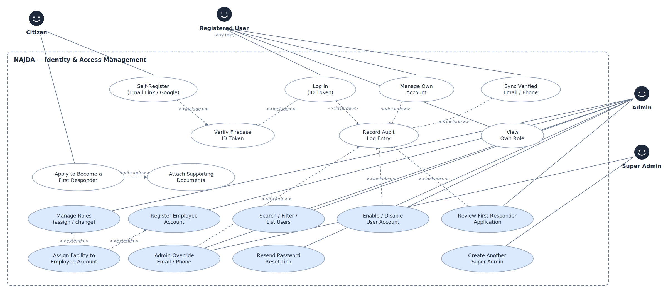
Figure 6.1 — Identity & Access Management use cases

UC-1 — Citizen Self-Registration
Field | Detail
Actor | Citizen
Platform | Web, Mobile
Preconditions | The person has no NAJDA account and has accepted the Terms & Conditions and Privacy Policy.
Postconditions (success) | A citizen account exists with a confirmed email, a completed profile, and a password.
Postconditions (failure) | No database record exists for an unconfirmed email address.
Main flow:
- The citizen enters an email address and accepts the terms, or chooses Continue with Google.
- The system sends a passwordless sign-in link to the address. No account exists yet.
- The citizen opens the link. On the same browser the email is recalled automatically; on another device the citizen re-enters it once.
- Firebase confirms the link, signs the citizen in, and marks the email verified in the same step.
- The system creates the NAJDA user record with blank names and profileCompleted = false.
- The profile gate routes the citizen to profile completion: first and last name, phone number (+20, validated), address, gender, and a password that meets the strength rules.
- The system saves the profile; with a phone number, address, gender, and a password provider present the profile is complete and the citizen enters the app.
Alternate flow — Google:
- At step 1 the citizen chooses Google; Google asserts the email.
- The system creates the user record immediately with the Google name; the citizen still completes phone, address, and gender (no password is required).
Alternate flow — resuming an abandoned registration:
- If the citizen requests a new link for an email that already has a record, the system treats the existing record as success and continues at step 6.
Alternate flow — email already registered:
- As the citizen types, the form shows whether the address already has an account and offers sign-in instead.
Exception flow — invalid or expired link:
- The system shows an error and the citizen requests a new link.
UC-2 — Admin-Provisioned Employee Registration
Field | Detail
Actor | Admin, Super Admin
Platform | Web
Preconditions | The caller holds ADMIN or SUPER_ADMIN. Creating a SUPER_ADMIN additionally requires the caller to be a Super Admin.
Postconditions (success) | A Firebase account and a matching NAJDA user exist with the requested role (and facility, where applicable), and a one-time password-reset link has been generated.
Postconditions (failure) | No orphaned Firebase account is left behind — if the database write fails, the Firebase account is deleted.
Main flow:
- The admin enters the employee's name, email, phone, address, gender, and role.
- If the role links to a facility, the admin selects a facility of the matching type (required for Hospital Staff). The facility is marked registered.
- The system creates a Firebase account with a generated temporary password and the matching user record, and sets the role claim.
- For a First Responder the system also creates a personal response unit.
- The system generates a password-reset link and returns it. It is not emailed; the admin shares it so the employee can set their own password.
Alternate flow — requested role is SUPER_ADMIN and caller is not:
- The request is rejected with access denied before any account is created.
UC-3 — Enable / Disable a User Account
Field | Detail
Actor | Admin, Super Admin
Platform | Web
Preconditions | The target is not a Super Admin unless the caller is also a Super Admin; the last enabled Super Admin cannot be disabled.
Postconditions (success) | The account's enabled flag is flipped; a disabled account can no longer authenticate.
Main flow:
- The admin opens the user and toggles Enable / Disable.
- The system updates the flag and timestamp; the change takes effect on the user's next request.
UC-4 — Assign or Change a User's Role
Field | Detail
Actor | Admin, Super Admin
Platform | Web
Preconditions | Same Super Admin protection as UC-3.
Postconditions (success) | The user's role (and facility, where relevant) is updated and the role claim re-synchronized.
Main flow:
- The admin selects a new role.
- If the role links to a facility the admin selects one of the matching type; if it does not, any existing link is cleared.
- The system saves the change and re-syncs the role claim so authorization reflects it immediately.
UC-5 — First Responder Certification Application
Field | Detail
Actor | Citizen (applicant); Admin, Super Admin (reviewer)
Platform | Web
Preconditions | The applicant's email and phone are verified and they have no pending application.
Postconditions (success) | Approved: the account's role is FIRST_RESPONDER with a personal unit. Rejected: the applicant may apply again.
Main flow:
- The citizen writes a motivation and attaches at least one document (image, PDF, or Word).
- The system stores the application and every document in a single request; an application never exists without its documents.
- An admin opens the pending application and views each document through a short-lived signed link.
- The admin approves; the system sets the role to First Responder and creates the applicant's personal unit.
Alternate flow — rejected:
- At step 4 the admin rejects with an optional reason; the applicant sees it and may re-apply.
Alternate flow — document removed:
- An admin may remove a document, which deletes the file from storage and the record.
UC-30 — Administer User Accounts
Field | Detail
Actor | Admin, Super Admin
Platform | Web
Preconditions | The caller holds ADMIN or SUPER_ADMIN.
Postconditions (success) | The requested change is applied; privileged phone overrides are audit-logged.
Main flow:
- The admin searches and filters the user list by name, email, phone, role, and enabled state.
- The admin opens a user and may edit profile fields, override the email (the identity record is updated and re-verification is required), generate a password-reset link, enable or disable the account (UC-3), or change the role (UC-4).
- A Super Admin may also override the phone number; the system writes an audit entry with the previous and new values, and refuses a number that is already verified on another account.
UC-31 — Manage Own Account
Field | Detail
Actor | Any authenticated user
Platform | Web, Mobile
Preconditions | The user is signed in.
Postconditions (success) | The user's own profile, email, phone, or password reflects the change.
Main flow:
- The user edits name, address, or gender and saves.
- To change email, the user enters the new address; a confirmation link is sent and the email changes only when the link is opened.
- To change phone, the user saves the number (unverified), then verifies it with a one-time code; a number already verified elsewhere is refused.
- To change password, the user re-enters the current password and the new one (accounts that sign in with Google have no password to change).

6.2 Emergency Reporting
The citizen's reporting experience, with the automated AI and geocoding services that act on a new report.
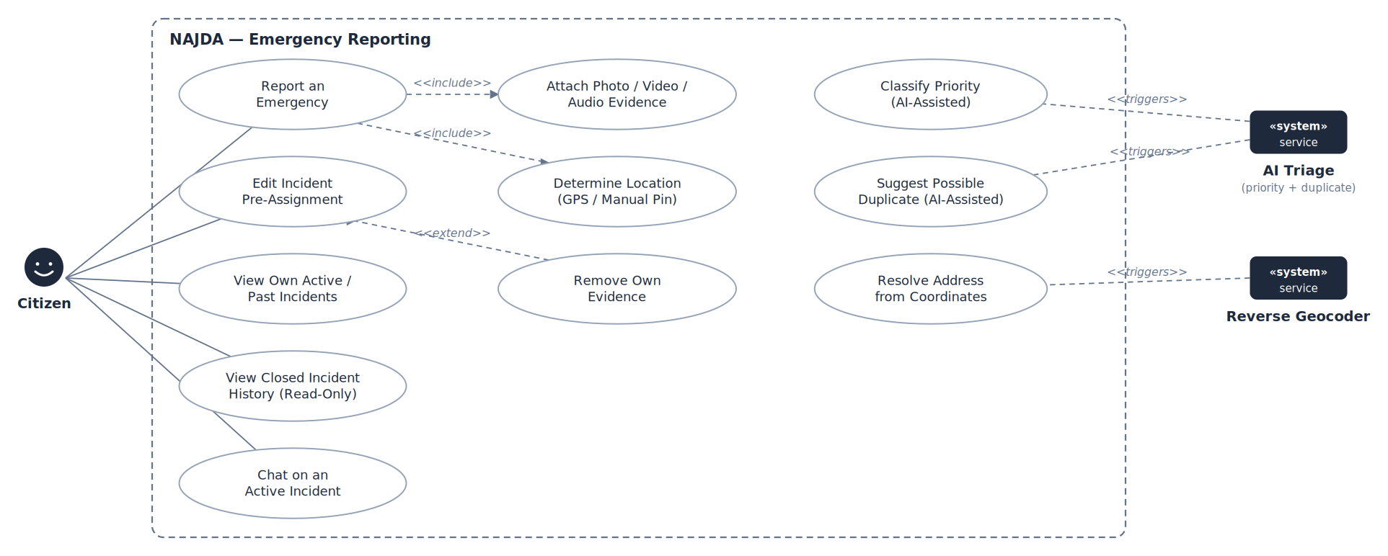
Figure 6.2 — Emergency Reporting use cases

UC-6 — Report an Emergency
Field | Detail
Actor | Citizen
Platform | Web, Mobile (evidence attachment: Web)
Preconditions | The citizen is signed in, has a completed profile, and has no active incident.
Postconditions (success) | An incident exists in NEW status; AI priority, duplicate suggestion, and address populate asynchronously.
Postconditions (failure) | No incident is created.
Main flow:
- The citizen presses the SOS control and chooses a category: Medical, Fire, or Police.
- The citizen optionally describes the situation and sets the injured count (default zero).
- The location comes from device GPS or a manually placed pin; a point outside Egypt is rejected.
- (Web) The citizen may attach photo, video, or audio. Each file is uploaded straight to private storage through a short-lived signed URL, then registered with the incident once the system confirms the file exists.
- The citizen submits. The system creates the incident (NEW) and pushes it to every connected dispatcher.
- In the background the system requests AI priority classification, an AI duplicate check, and a reverse-geocoded address; none of these delays the response.
Alternate flow — partial evidence failure:
- If some files fail to upload but the incident exists, the citizen is told how many failed; the incident stays valid and dispatchable.
Exception flow — active incident exists:
- The system rejects the submission with a conflict; the citizen is shown their existing incident.
UC-17 — Edit an Incident Before Assignment
Field | Detail
Actor | Citizen
Platform | Web (mobile: description and injured count)
Preconditions | The incident belongs to the citizen and is NEW, AI_PROCESSED, or DISPATCHER_REVIEW.
Postconditions (success) | The incident reflects the edit and connected dispatchers see it immediately.
Postconditions (failure) | Editing is refused once a unit is assigned.
Main flow:
- The citizen edits the description, changes the injured count, or adds or removes evidence.
- The system saves and pushes the update.
Exception flow — already assigned:
- The system rejects the edit with a conflict, because a responder or dispatcher may already be acting on what was reported.
UC-18 — View Closed Incident History
Field | Detail
Actor | Citizen; any user who participated in the incident (including a responder whose mission has completed)
Platform | Web
Preconditions | The incident is RESOLVED or CANCELLED.
Postconditions (success) | None — read-only.
Postconditions (failure) | A user who never took part receives access denied.
Main flow:
- The user opens the incident from their history.
- The system shows category, status, map, address, original message, evidence, and the full chat transcript, all read-only.
UC-19 — Chat on an Incident
Field | Detail
Actor | Citizen, Dispatcher, Admin, responder on an active mission
Platform | Web
Preconditions | The incident is not closed. Sending is limited to those actors; anyone who ever participated may read.
Postconditions (success) | The message is stored encrypted and delivered live to every connected participant.
Main flow:
- The actor types a message and sends.
- The system verifies the sender may write to this incident, encrypts and stores the message, and pushes it to subscribers.

6.3 Dispatch Operations
Admin and Super Admin hold every Dispatcher capability shown here; Delete an Incident is restricted to Super Admin.
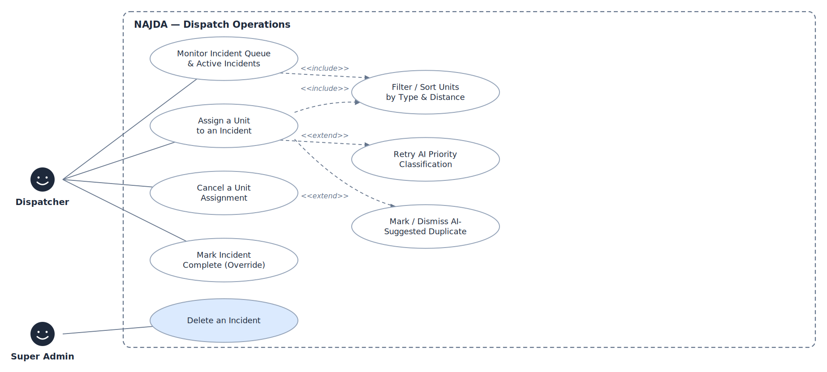
Figure 6.3 — Dispatch Operations use cases

UC-7 — Assign a Unit to an Incident
Field | Detail
Actor | Dispatcher, Admin, Super Admin
Platform | Web
Preconditions | The incident is not RESOLVED or CANCELLED.
Postconditions (success) | A mission exists in OFFERED status, the unit is BUSY, and the incident is ASSIGNED.
Main flow:
- The dispatcher monitors the live queue and opens an incident; the live map shows it with every relevant unit.
- The dispatcher filters units by type; the list is sorted nearest-first using each unit's live position or its home facility, with an estimated arrival time.
- The dispatcher selects a unit on the map or in the list and confirms.
- The system locks the unit row, verifies it is still AVAILABLE, creates the mission (OFFERED), marks the unit BUSY, and snapshots the crew currently on shift as mission participants.
- On the first assignment the incident becomes ASSIGNED; additional units on the same incident do not repeat the transition.
- The responding LEAD is notified live.
Exception flow — unit no longer available:
- If another dispatcher claimed the unit first, the second attempt fails cleanly with a conflict.
UC-29 — Cancel a Unit Assignment
Field | Detail
Actor | Dispatcher, Admin, Super Admin
Platform | Web
Preconditions | The mission is not COMPLETED, CANCELLED, or REJECTED.
Postconditions (success) | The mission is CANCELLED, the unit is AVAILABLE, and the incident returns to DISPATCHER_REVIEW if no other mission is still active.
Main flow:
- The dispatcher chooses Cancel assignment on a mission and confirms.
- The system cancels the mission, frees the unit, and reopens the incident for reassignment if nothing else is working it.
UC-13 — Retry AI Priority Classification
Field | Detail
Actor | Dispatcher, Admin, Super Admin
Platform | Web
Preconditions | The incident has no AI priority.
Postconditions (success) | Priority and confidence populate, or remain unset if the retry fails.
Main flow:
- The dispatcher chooses Retry AI.
- The system re-runs classification in the background and pushes the result when it completes.
UC-14 — Mark or Dismiss a Duplicate
Field | Detail
Actor | Dispatcher, Admin, Super Admin
Platform | Web
Preconditions | The incident carries an AI-suggested duplicate, or the dispatcher chooses to mark one manually.
Postconditions (success) | Confirmed: the incident is cancelled and linked to the original. Dismissed: the suggestion is cleared.
Main flow:
- The dispatcher reviews the suggestion with its confidence.
- On Confirm the system links the incident to the original as a duplicate and cancels it, recording reason, actor, and time.
Alternate flow — dismiss:
- The dispatcher chooses Not a duplicate; the system clears the suggestion and the incident continues.
Alternate flow — manual:
- The dispatcher picks any other open incident from the queue as the original.
UC-15 — Mark an Incident Complete (Override)
Field | Detail
Actor | Dispatcher, Admin, Super Admin
Platform | Web
Preconditions | The incident is not RESOLVED or CANCELLED.
Postconditions (success) | The incident is RESOLVED, every active mission is COMPLETED, and every involved unit is AVAILABLE.
Main flow:
- The dispatcher chooses Mark Incident Complete and confirms the warning.
- The system completes every active mission, frees every unit, and resolves the incident.
UC-16 — Delete an Incident
Field | Detail
Actor | Super Admin
Platform | Web
Preconditions | None beyond the role — the action is unconditional and irreversible.
Postconditions (success) | The incident, its missions, chat, and hospital transfers are removed and any unit still busy on it is freed.
Main flow:
- The Super Admin chooses Delete incident and confirms the explicit warning.
- The system frees any busy unit, removes dependent records, then the incident.

6.4 Field Response & Shift Management
The responder's duty cycle and mission progression. Force-ending a shift is an administrative recovery action.
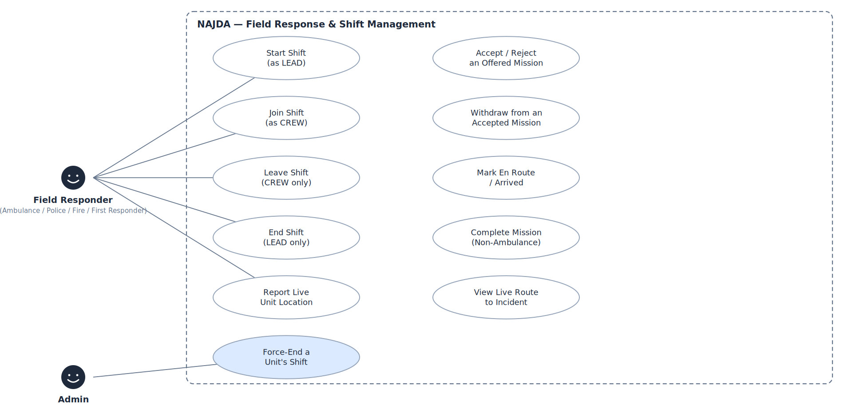
Figure 6.4 — Field Response & Shift Management use cases

UC-10 — Start, Join, Leave, and End a Shift
Field | Detail
Actor | Ambulance Crew, Police, Firefighter, First Responder
Platform | Web, Mobile
Preconditions | The employee has no active shift. Roles tied to a facility may only use units at their own facility; Ambulance Crew and First Responder are exempt from that restriction. A First Responder sees only their own unit.
Postconditions (success) | The shift record reflects the change and the unit's availability follows it.
Main flow:
- To start, the employee selects a unit that has no LEAD; the system opens a LEAD shift and the unit becomes available.
- To join, the employee selects a unit that already has a LEAD and joins as CREW.
- A CREW member may leave at any time.
- The LEAD ends the shift, which closes every open shift on the unit.
Exception flow — ineligible:
- If the unit belongs to another facility, or the employee already has an active shift, the system refuses with an explanatory message.
UC-8 — Work a Mission
Field | Detail
Actor | Unit LEAD (CREW members see the mission but do not act on it)
Platform | Web, Mobile
Preconditions | The employee is the active LEAD of the unit and a mission is OFFERED to it.
Postconditions (success) | The mission reaches COMPLETED (or CANCELLED / REJECTED); the unit is AVAILABLE again.
Main flow:
- The LEAD is notified live and accepts the offered mission; it becomes ACCEPTED.
- The LEAD marks the unit en route; the live route map and shared location guide the way.
- The LEAD marks arrival on scene (ARRIVED).
- For non-ambulance units the LEAD completes the mission; the unit is freed, and when every mission on the incident is complete the incident resolves.
- For an ambulance the LEAD continues with the hospital handoff (UC-9).
Alternate flow — reject:
- At step 1 the LEAD rejects with a reason; the mission becomes REJECTED and the unit is freed so the dispatcher can assign another.
Alternate flow — withdraw:
- While the mission is ACCEPTED or EN_ROUTE, the LEAD may withdraw (with confirmation); the mission is CANCELLED, the unit is freed, and the incident is reopened if nothing else is working it.
- After arrival the LEAD must ask a dispatcher to cancel instead.
Exception flow — not the LEAD:
- Any mission action by someone who is not the unit's active LEAD is refused by the server.
UC-12 — Report Live Unit Location
Field | Detail
Actor | Unit LEAD
Platform | Web, Mobile
Preconditions | The employee is the active LEAD and has granted location permission.
Postconditions (success) | The unit's position is stored and every dispatch map updates live.
Main flow:
- While on shift the device watches its position and sends an update at most every 15 seconds.
- The shift card shows the sharing state: live with the last update time, waiting for GPS, permission denied, unsupported, or error.
- The LEAD may pause and resume sharing.
Alternate flow — no live position:
- Dispatch views fall back to the unit's home facility location and label it as such.
UC-11 — Force-End a Unit's Shift
Field | Detail
Actor | Admin, Super Admin
Platform | Web
Preconditions | The unit has an active LEAD.
Postconditions (success) | Every open shift on the unit is closed and the unit is OFFLINE.
Main flow:
- The admin opens the unit list and chooses Force End Shift on a unit with an active LEAD.
- The system closes every open shift on that unit.

6.5 Hospital Coordination
Destination selection and live patient vitals for ambulance missions, and the hospital's view of the inbound patient.
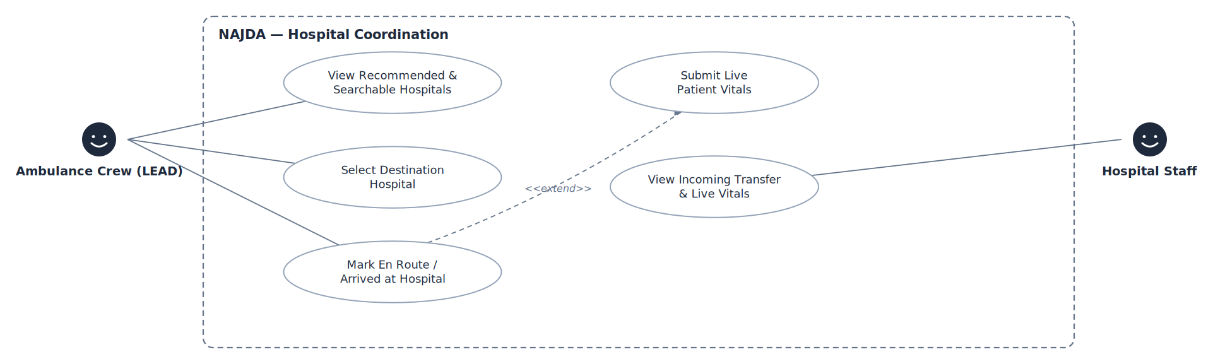
Figure 6.5 — Hospital Coordination use cases

UC-9 — Ambulance Hospital Handoff
Field | Detail
Actor | Ambulance Crew (LEAD)
Platform | Web
Preconditions | The ambulance mission is ARRIVED and has no transfer yet.
Postconditions (success) | The transfer is ARRIVED, the mission is COMPLETED, the unit is AVAILABLE, and the incident resolves when all its missions are complete.
Main flow:
- The system lists hospitals within 30 km of the incident ranked by distance from the incident, with the nearest recommended, and the full list is searchable. The map shows the incident, every hospital, the recommended hospital, and the crew's own base.
- The LEAD hovers to highlight and clicks to select a hospital, then confirms; the transfer is SELECTED.
- The LEAD marks the transfer en route; the route map guides the crew to the hospital.
- While en route the LEAD submits patient vitals (UC-20 shows them live to the hospital).
- The LEAD marks arrival; the mission completes and the unit is freed.
Alternate flow — destination not in the system:
- The LEAD enters a hospital name as free text; the transfer proceeds, but live vitals are not accepted because there is no registered hospital to receive them.
Exception flow — hospital not registered:
- Vitals submitted for a hospital with no linked staff are refused with an explanatory message.
UC-20 — View Incoming Transfer and Live Vitals
Field | Detail
Actor | Hospital Staff
Platform | Web
Preconditions | The account is linked to a hospital.
Postconditions (success) | None — read-only.
Postconditions (failure) | An account with no facility link sees a message to contact an administrator.
Main flow:
- The staff member sees incoming transfers for their hospital and a list of arrived patients.
- Selecting a transfer shows a map of the pickup location and the inbound unit.
- The vitals panel updates live as the crew submits readings.

6.6 Facility & System Administration
Facility and unit management, data seeding, and reconciliation tools. Blue use cases are restricted to Super Admin.
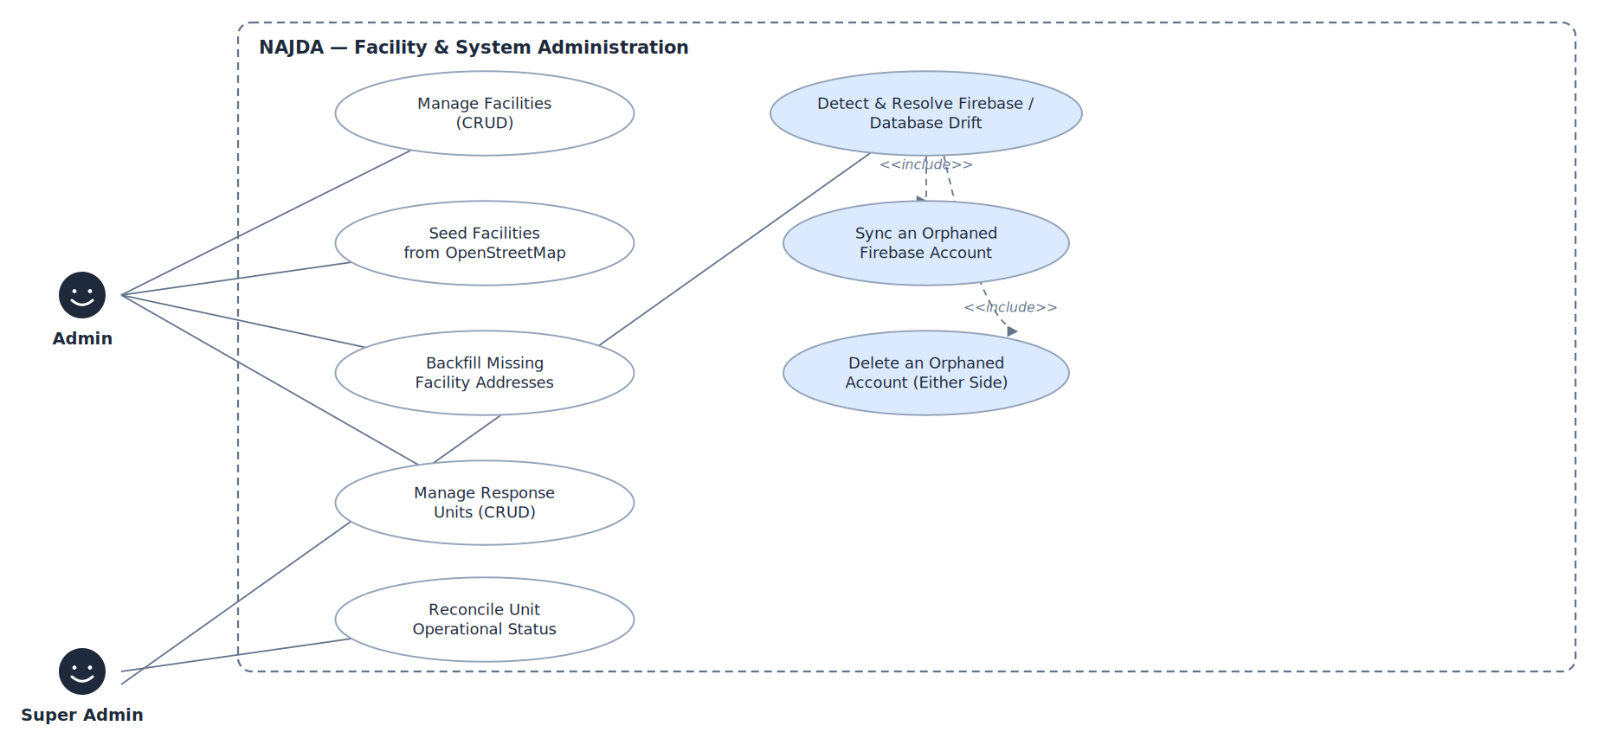
Figure 6.6 — Facility & System Administration use cases

UC-21 — Manage Facilities
Field | Detail
Actor | Admin, Super Admin
Platform | Web
Preconditions | The caller holds ADMIN or SUPER_ADMIN.
Postconditions (success) | The facility is saved.
Main flow:
- The admin lists facilities with search and a type filter.
- The admin creates a facility (type, name, address, coordinates) or edits one; the type cannot change after creation.
- The registered flag is never set by hand: it turns on when staff or a unit is linked.
UC-22 — Seed Facilities from OpenStreetMap
Field | Detail
Actor | Admin, Super Admin
Platform | Web
Preconditions | Seeding is available for Hospital, Fire, and Police facilities (ambulance stations are added manually).
Postconditions (success) | New facilities exist, unregistered, with addresses where available.
Main flow:
- The admin chooses a facility type.
- The system queries OpenStreetMap for that type across Egypt through a pool of mirrors, skipping unnamed records and any record whose coordinates already exist.
- For each new facility the address comes from OSM tags or, if absent, from reverse geocoding paced to the service's rate limit.
Alternate flow — rate limited:
- If the geocoding service rate-limits, the run stops cleanly with a single log message; the admin can re-run later.
UC-23 — Backfill Missing Facility Addresses
Field | Detail
Actor | Admin, Super Admin
Platform | Web
Preconditions | At least one facility has no address.
Postconditions (success) | Addresses are filled where the geocoder succeeds.
Main flow:
- The admin chooses Fill missing addresses.
- The system retries reverse geocoding for each facility with no address, paced to the service limit, and stops on a rate-limit response.
UC-24 — Manage Response Units
Field | Detail
Actor | Admin, Super Admin
Platform | Web
Preconditions | The caller holds ADMIN or SUPER_ADMIN.
Postconditions (success) | The unit is saved or removed.
Main flow:
- The admin creates or edits a unit: type, plate number, and home station.
- The home station picker offers only facilities of a matching type — fire trucks at fire stations, police cars at police stations, ambulances at ambulance stations or hospitals; a First Responder unit has no station.
- The admin may delete a unit; a unit still in use is refused with a conflict.
UC-25 — Reconcile Unit Operational Status
Field | Detail
Actor | Admin, Super Admin
Platform | Web
Preconditions | None.
Postconditions (success) | No unit remains BUSY without an active mission.
Main flow:
- The admin chooses Refresh on the unit list.
- The system finds every BUSY unit with no active mission and returns it to AVAILABLE. Units that are OFFLINE are never touched.
UC-26 — Detect and Resolve Firebase / Database Drift
Field | Detail
Actor | Super Admin
Platform | Web
Preconditions | The caller is a Super Admin. Intended for development setups where several environments share one Firebase project.
Postconditions (success) | Orphans are synced or removed.
Main flow:
- The Super Admin runs the check; the system compares every Firebase account with the database.
- For an account in Firebase only, the Super Admin may create a profile: the name is guessed from the email address, a verified Firebase phone number is carried over, and the profile is left incomplete.
- The Super Admin may instead delete an orphan on either side; the system refuses if the other side turns out to exist.

6.7 General & Support Services
Capabilities available to every user regardless of role.
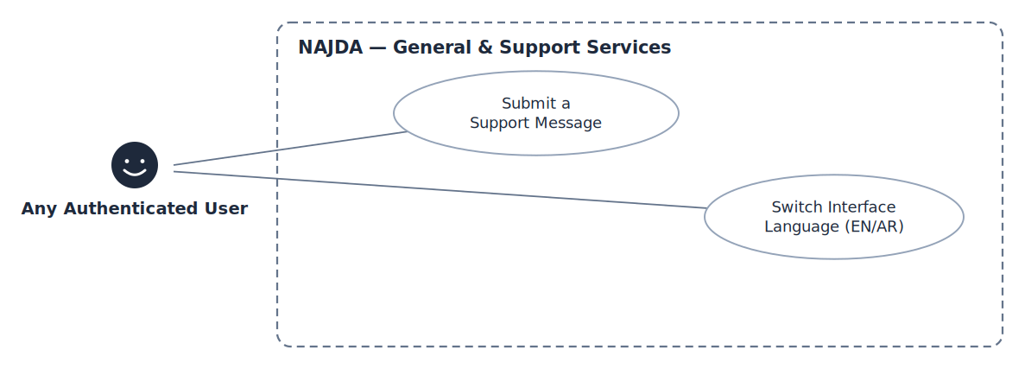
Figure 6.7 — General & Support Services use cases

UC-27 — Submit a Support Message
Field | Detail
Actor | Any user
Platform | Web, Mobile
Preconditions | None.
Postconditions (success) | The message is delivered to the support team by email.
Main flow:
- The user opens Support and enters a name, email, and message.
- The system sends it through the email service and confirms delivery.
UC-28 — Switch Interface Language
Field | Detail
Actor | Any user
Platform | Web, Mobile
Preconditions | None.
Postconditions (success) | The interface is shown in the chosen language and direction, remembered for next time.
Main flow:
- The user chooses English or Arabic.
- The interface switches instantly, without reloading; Arabic switches to right-to-left reading direction while numbers, phone numbers, and links stay left-to-right.

7 System Architecture and Design

7.1 Architecture Overview
NAJDA is a three-tier system with managed services for identity, object storage, and AI. Two clients — a Next.js web console and an Expo mobile application — talk to a single Spring Boot API over REST and a STOMP WebSocket. The API persists to PostgreSQL and integrates with external services for identity, media, AI classification, geocoding, and routing.
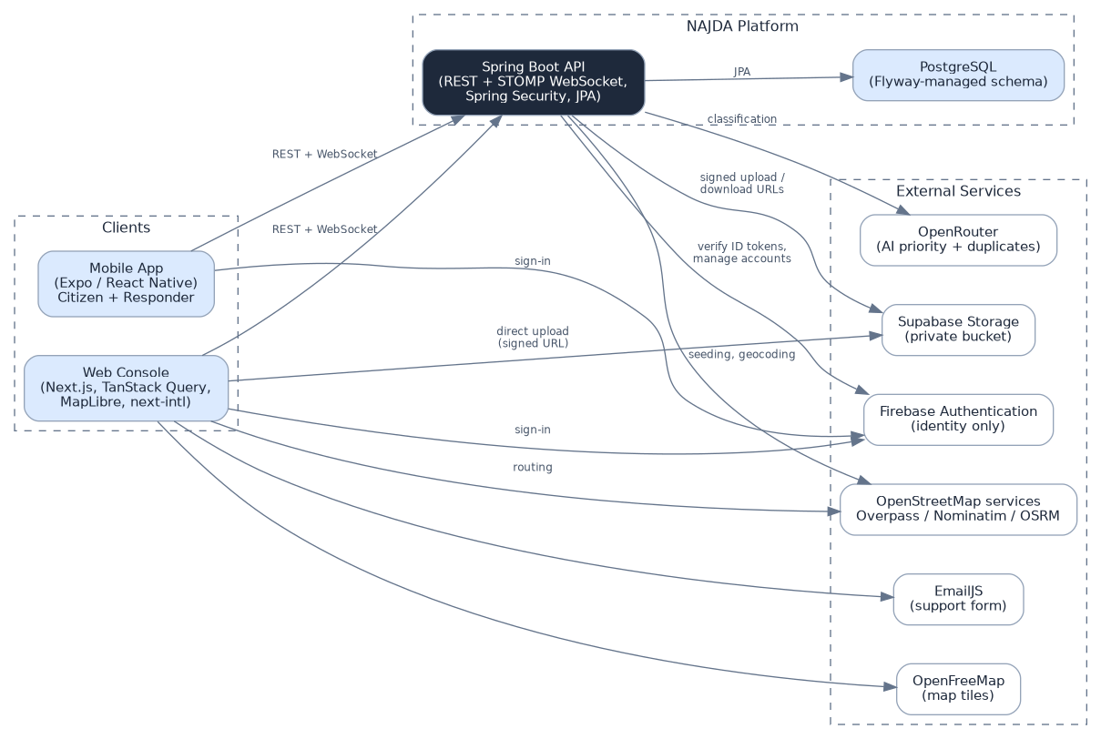
Figure 7.1 — System architecture and external services

Architectural principles
- Identity is delegated; authority is local. Firebase proves who someone is. The NAJDA database alone decides what they may do: roles, facility links, and everything that has happened.
- The backend is the security boundary. Authorization is enforced in the service layer; client-side gating only shapes the interface.
- Live by default. State changes are pushed over WebSocket so consoles react instead of polling.
- Asynchronous and advisory AI. Classification, duplicate checks, and geocoding run off the request path, and a failure never affects the incident.
- Private by default. Media is never public; sensitive text is encrypted before it reaches the database.
- One source of truth per fact. Facilities are one entity with a type; a shift record is the sole evidence a unit has an operator.

Real-time channels
The API exposes a STOMP endpoint at /ws backed by Spring's in-memory broker. Clients subscribe to topic channels and refresh the affected data when a message arrives.
Topic | Published when | Consumers
/topic/incidents | An incident is created, updated, classified, geocoded, or closed | Dispatch queue and detail, admin incidents, citizen view
/topic/missions | A mission is offered, accepted, progressed, cancelled, or completed | Dispatch, responder console
/topic/units | A unit's status or position changes | Dispatch map and unit lists, admin units
/topic/incidents/{id}/chat | A chat message is sent | Everyone viewing that incident's chat
/topic/hospital-transfers/{id}/vitals | Vitals are submitted for a transfer | Hospital dashboard

Deployment
The web console is deployed as a Next.js application and the API as a containerized Spring Boot service. For local use and reproduction, a single Docker Compose file starts PostgreSQL, the backend, and the web console together; configuration is supplied entirely through environment variables. The schema is created and evolved by Flyway migrations, and Hibernate is set to validate the schema at start-up.

7.2 Data Model
Conceptual entity-relationship model. Rectangles are entities, diamonds are relationships, and ovals are attributes. The figure is embedded at full resolution and can be enlarged in the digital copy; the class diagram (Section 7.3) and the data dictionary below give the same model in readable text form.
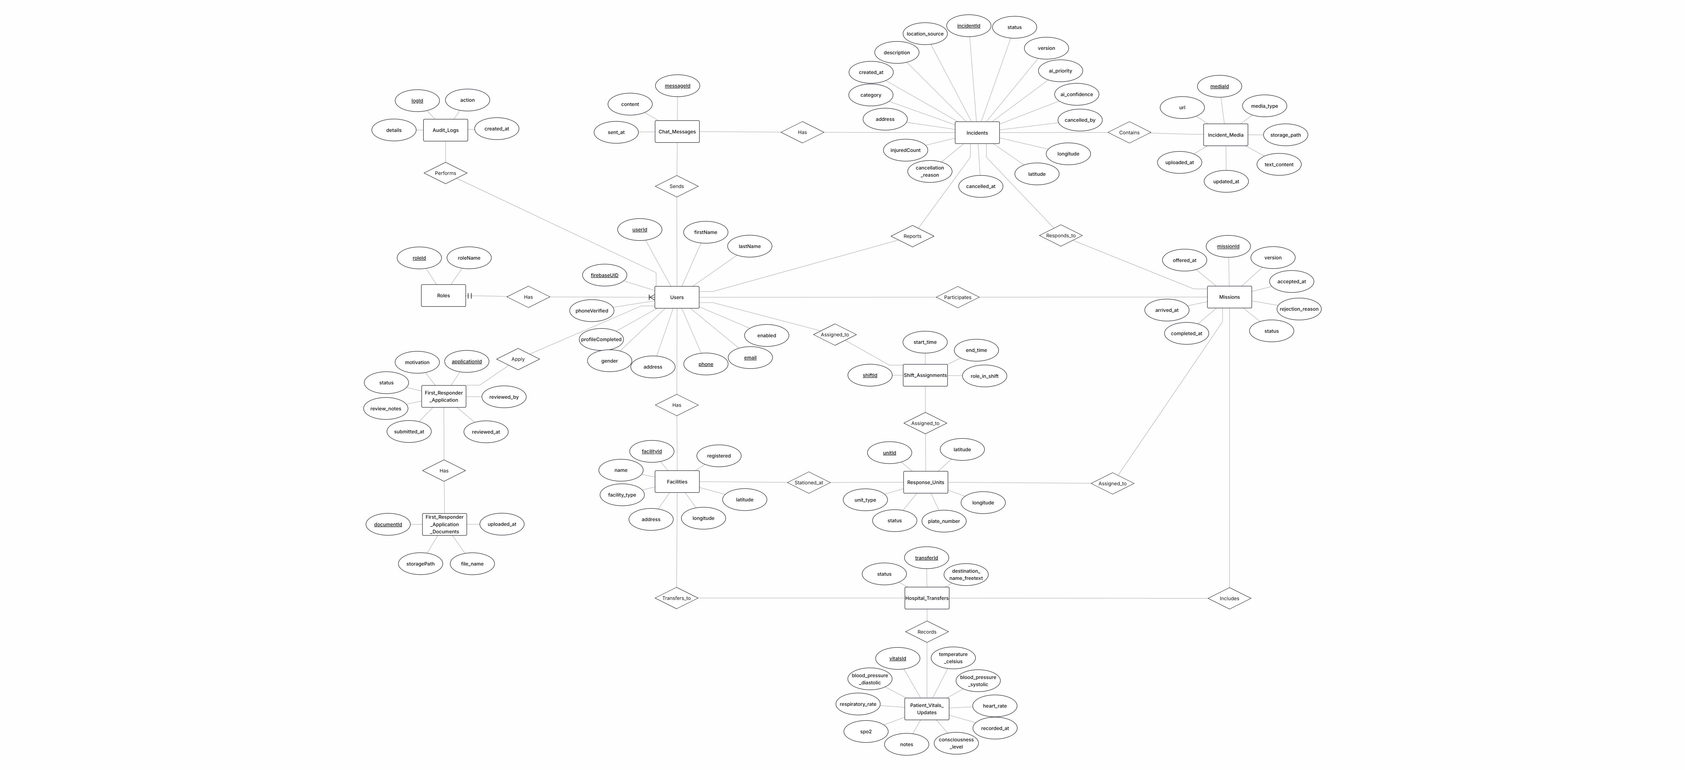
Figure 7.2 — Conceptual entity-relationship diagram

Physical schema as deployed in PostgreSQL, generated from the live database. Embedded at full resolution; the data dictionary that follows lists every column. Every foreign key shown is enforced; reviewed_by on applications and the actor and target columns on audit logs are deliberate soft references.
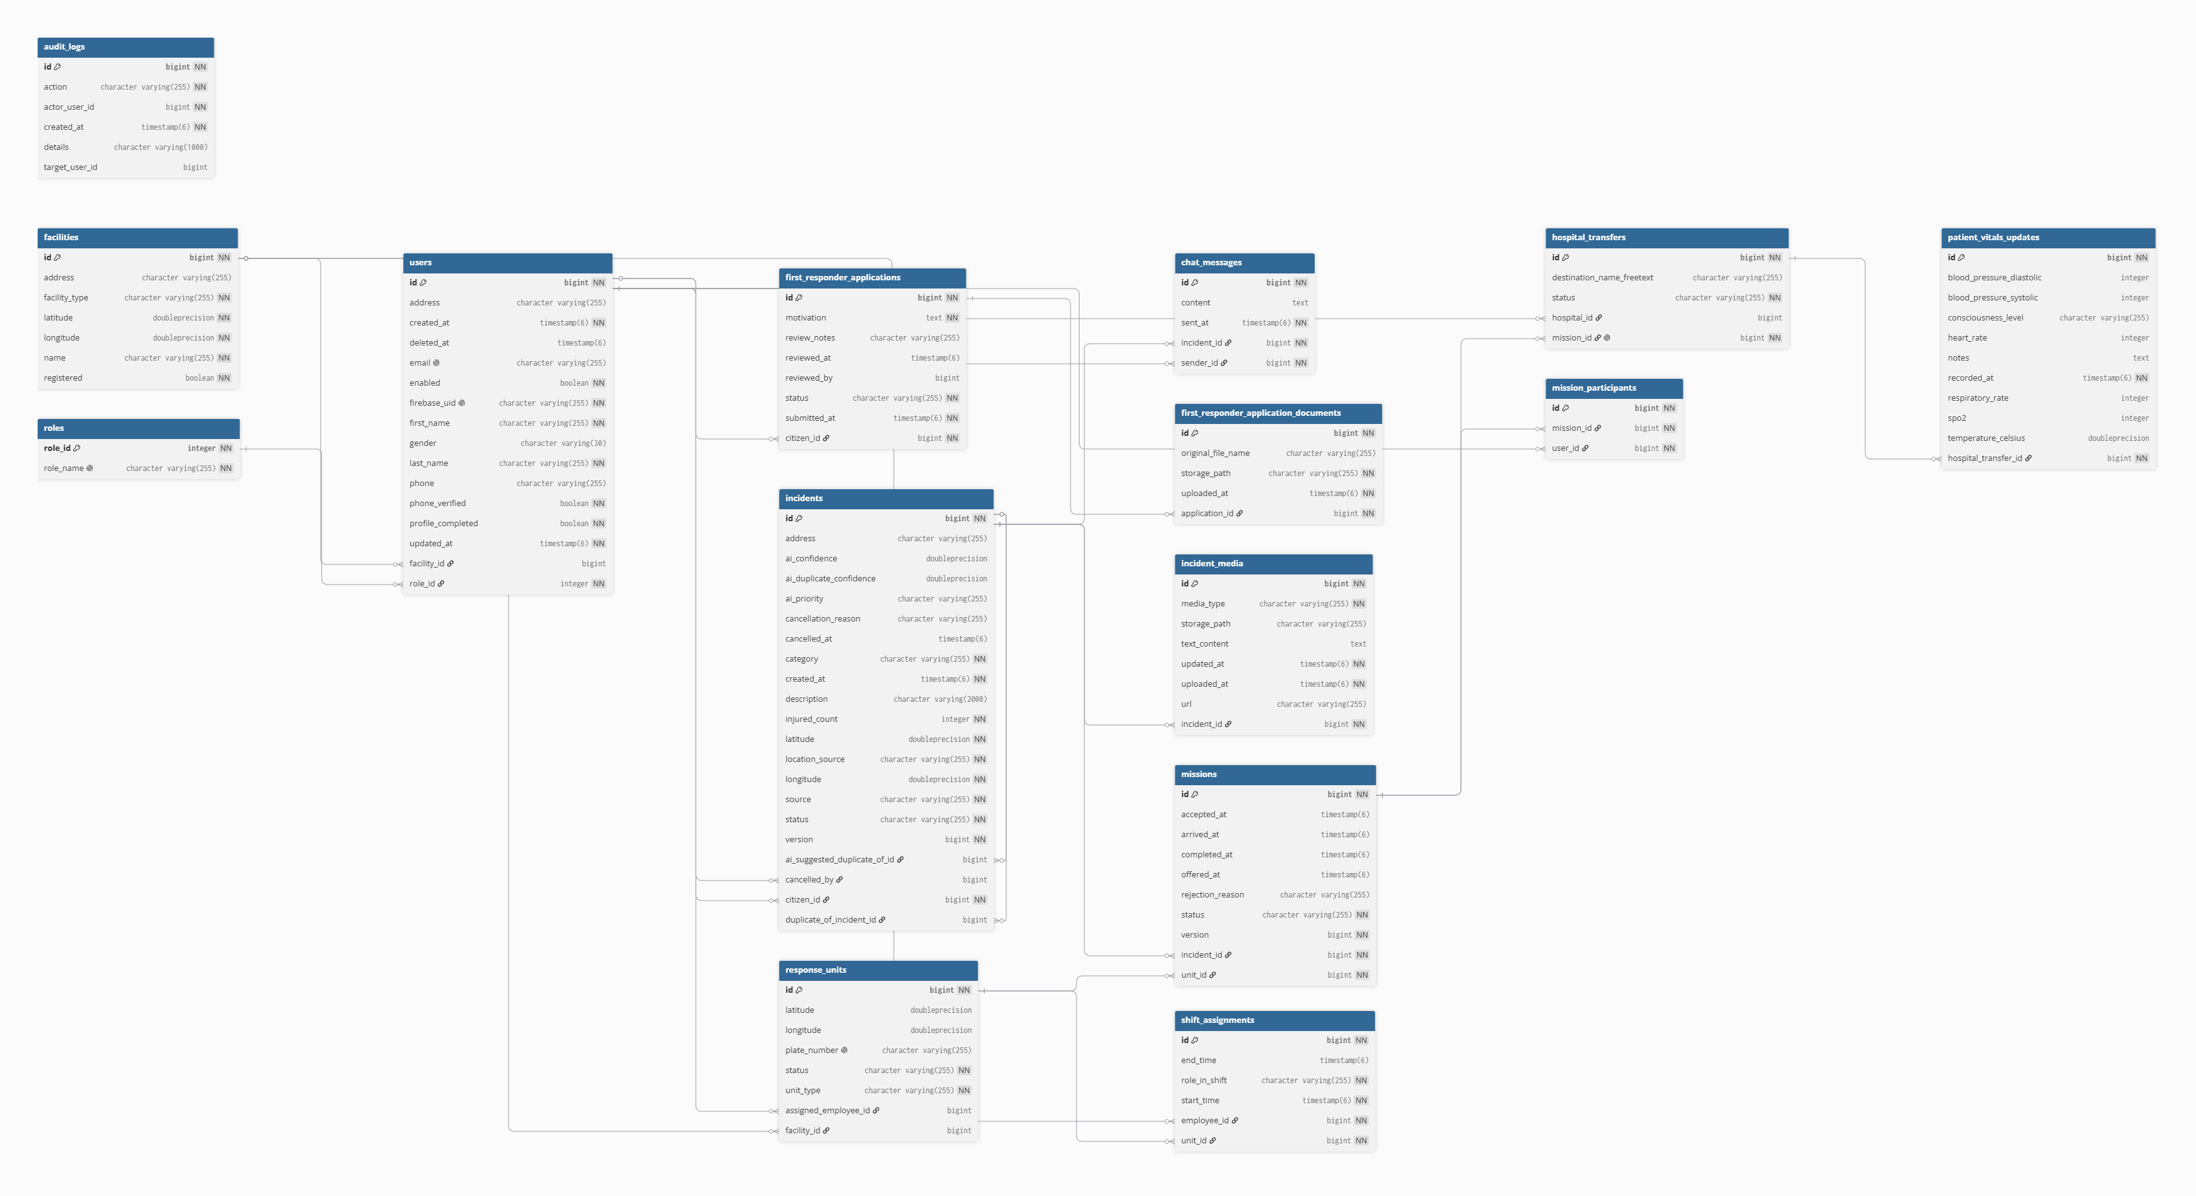
Figure 7.3 — Physical database schema

The schema enforces these notable constraints: user email and Firebase UID are unique; a unit's plate number is unique; each mission has at most one hospital transfer; every enumerated column is guarded by a check constraint. Phone-number uniqueness is deliberately not a database constraint — it applies only to verified numbers and is enforced in the application (Section 8, BR-18).

Data dictionary
Generated from the baseline migration. Enumerated columns list their permitted values. Columns that hold encrypted text are marked.
roles
Role catalogue (SUPER_ADMIN, ADMIN, DISPATCHER, HOSPITAL_STAFF, AMBULANCE_CREW, POLICE, FIREFIGHTER, FIRST_RESPONDER, CITIZEN).
Column | Type | Null | Constraints / notes
role_id | integer | no | PK
role_name | varchar(255) | no | UNIQUE

users
Every account. The Firebase UID links the row to the identity record; role and optional facility define access.
Column | Type | Null | Constraints / notes
id | bigint | no | PK
address | varchar(255) | yes
created_at | timestamp(6) | no
deleted_at | timestamp(6) | yes
email | varchar(255) | yes | UNIQUE
enabled | boolean | no
firebase_uid | varchar(255) | no | UNIQUE
first_name | varchar(255) | no
gender | varchar(30) | yes | one of: MALE, FEMALE
last_name | varchar(255) | no
phone | varchar(255) | yes
phone_verified | boolean | no
profile_completed | boolean | no
updated_at | timestamp(6) | no
facility_id | bigint | yes | FK → facilities
role_id | integer | no | FK → roles

facilities
Unified hospitals, ambulance stations, fire stations, and police stations.
Column | Type | Null | Constraints / notes
id | bigint | no | PK
address | varchar(255) | yes
facility_type | varchar(255) | no | one of: HOSPITAL, AMBULANCE_STATION, FIRE_STATION, POLICE_STATION
latitude | double precision | no
longitude | double precision | no
name | varchar(255) | no
registered | boolean | no

response_units
Vehicles (and personal First Responder units) that can be assigned to incidents.
Column | Type | Null | Constraints / notes
id | bigint | no | PK
latitude | double precision | yes
longitude | double precision | yes
plate_number | varchar(255) | yes | UNIQUE
status | varchar(255) | no | one of: AVAILABLE, BUSY, OFFLINE, MAINTENANCE
unit_type | varchar(255) | no | one of: AMBULANCE, FIRE_TRUCK, POLICE_CAR, FIRST_RESPONDER
assigned_employee_id | bigint | yes | FK → users
facility_id | bigint | yes | FK → facilities

shift_assignments
Who is on duty for which unit, and as LEAD or CREW.
Column | Type | Null | Constraints / notes
id | bigint | no | PK
end_time | timestamp(6) | yes
role_in_shift | varchar(255) | no | one of: LEAD, CREW
start_time | timestamp(6) | no
employee_id | bigint | no | FK → users
unit_id | bigint | no | FK → response_units

incidents
The central record of an emergency, with AI output, location, lifecycle status, and duplicate links.
Column | Type | Null | Constraints / notes
id | bigint | no | PK
address | varchar(255) | yes
ai_confidence | double precision | yes
ai_duplicate_confidence | double precision | yes
ai_priority | varchar(255) | yes | one of: CRITICAL, HIGH, MEDIUM, LOW
cancellation_reason | varchar(255) | yes
cancelled_at | timestamp(6) | yes
category | varchar(255) | no | one of: MEDICAL, POLICE, FIRE
created_at | timestamp(6) | no
description | varchar(2000) | yes
injured_count | integer | no
latitude | double precision | no
location_source | varchar(255) | no | one of: GPS, MANUAL_PIN
longitude | double precision | no
source | varchar(255) | no | one of: CITIZEN_APP, SENSOR_DEVICE
status | varchar(255) | no | one of: NEW, AI_PROCESSED, DISPATCHER_REVIEW, ASSIGNED, IN_PROGRESS, RESOLVED, CANCELLED
version | bigint | no
ai_suggested_duplicate_of_id | bigint | yes | FK → incidents
cancelled_by | bigint | yes | FK → users
citizen_id | bigint | no | FK → users
duplicate_of_incident_id | bigint | yes | FK → incidents

incident_media
Text and evidence attached to an incident; media is stored by private bucket path, never by public URL.
Column | Type | Null | Constraints / notes
id | bigint | no | PK
media_type | varchar(255) | no | one of: PHOTO, VIDEO, AUDIO, TEXT
storage_path | varchar(255) | yes
text_content | text | yes | encrypted at rest
updated_at | timestamp(6) | no
uploaded_at | timestamp(6) | no
url | varchar(255) | yes
incident_id | bigint | no | FK → incidents

missions
One unit's assignment to one incident, with its own lifecycle.
Column | Type | Null | Constraints / notes
id | bigint | no | PK
accepted_at | timestamp(6) | yes
arrived_at | timestamp(6) | yes
completed_at | timestamp(6) | yes
offered_at | timestamp(6) | yes
rejection_reason | varchar(255) | yes
status | varchar(255) | no | one of: OFFERED, ACCEPTED, REJECTED, EN_ROUTE, ARRIVED, COMPLETED, CANCELLED
version | bigint | no
incident_id | bigint | no | FK → incidents
unit_id | bigint | no | FK → response_units

mission_participants
Snapshot of the crew on shift when a mission was offered.
Column | Type | Null | Constraints / notes
id | bigint | no | PK
mission_id | bigint | no | FK → missions
user_id | bigint | no | FK → users

hospital_transfers
The destination and progress of an ambulance mission's patient handoff (one per mission).
Column | Type | Null | Constraints / notes
id | bigint | no | PK
destination_name_freetext | varchar(255) | yes
status | varchar(255) | no | one of: SELECTED, EN_ROUTE, ARRIVED
hospital_id | bigint | yes | FK → facilities
mission_id | bigint | no | UNIQUE; FK → missions

patient_vitals_updates
Time-stamped vitals transmitted during a transfer.
Column | Type | Null | Constraints / notes
id | bigint | no | PK
blood_pressure_diastolic | integer | yes
blood_pressure_systolic | integer | yes
consciousness_level | varchar(255) | yes | one of: ALERT, VERBAL, PAIN, UNRESPONSIVE
heart_rate | integer | yes
notes | text | yes | encrypted at rest
recorded_at | timestamp(6) | no
respiratory_rate | integer | yes
spo2 | integer | yes
temperature_celsius | double precision | yes
hospital_transfer_id | bigint | no | FK → hospital_transfers

chat_messages
Per-incident conversation; content is encrypted at rest.
Column | Type | Null | Constraints / notes
id | bigint | no | PK
content | text | yes | encrypted at rest
sent_at | timestamp(6) | no
incident_id | bigint | no | FK → incidents
sender_id | bigint | no | FK → users

first_responder_applications
A citizen's application to become a First Responder.
Column | Type | Null | Constraints / notes
id | bigint | no | PK
motivation | text | no
review_notes | varchar(255) | yes
reviewed_at | timestamp(6) | yes
reviewed_by | bigint | yes
status | varchar(255) | no | one of: PENDING, APPROVED, REJECTED
submitted_at | timestamp(6) | no
citizen_id | bigint | no | FK → users

first_responder_application_documents
Supporting documents attached to an application, stored by private bucket path.
Column | Type | Null | Constraints / notes
id | bigint | no | PK
original_file_name | varchar(255) | yes
storage_path | varchar(255) | no
uploaded_at | timestamp(6) | no
application_id | bigint | no | FK → first_responder_applications

audit_logs
Record of privileged identity changes (actor, action, target, details).
Column | Type | Null | Constraints / notes
id | bigint | no | PK
action | varchar(255) | no
actor_user_id | bigint | no
created_at | timestamp(6) | no
details | varchar(1000) | yes
target_user_id | bigint | yes

7.3 Class Design
The domain model below shows the persistent entities, their key attributes, and their associations. Diamonds mark composition (a child that cannot exist without its parent); dashed arrows mark optional or self references.
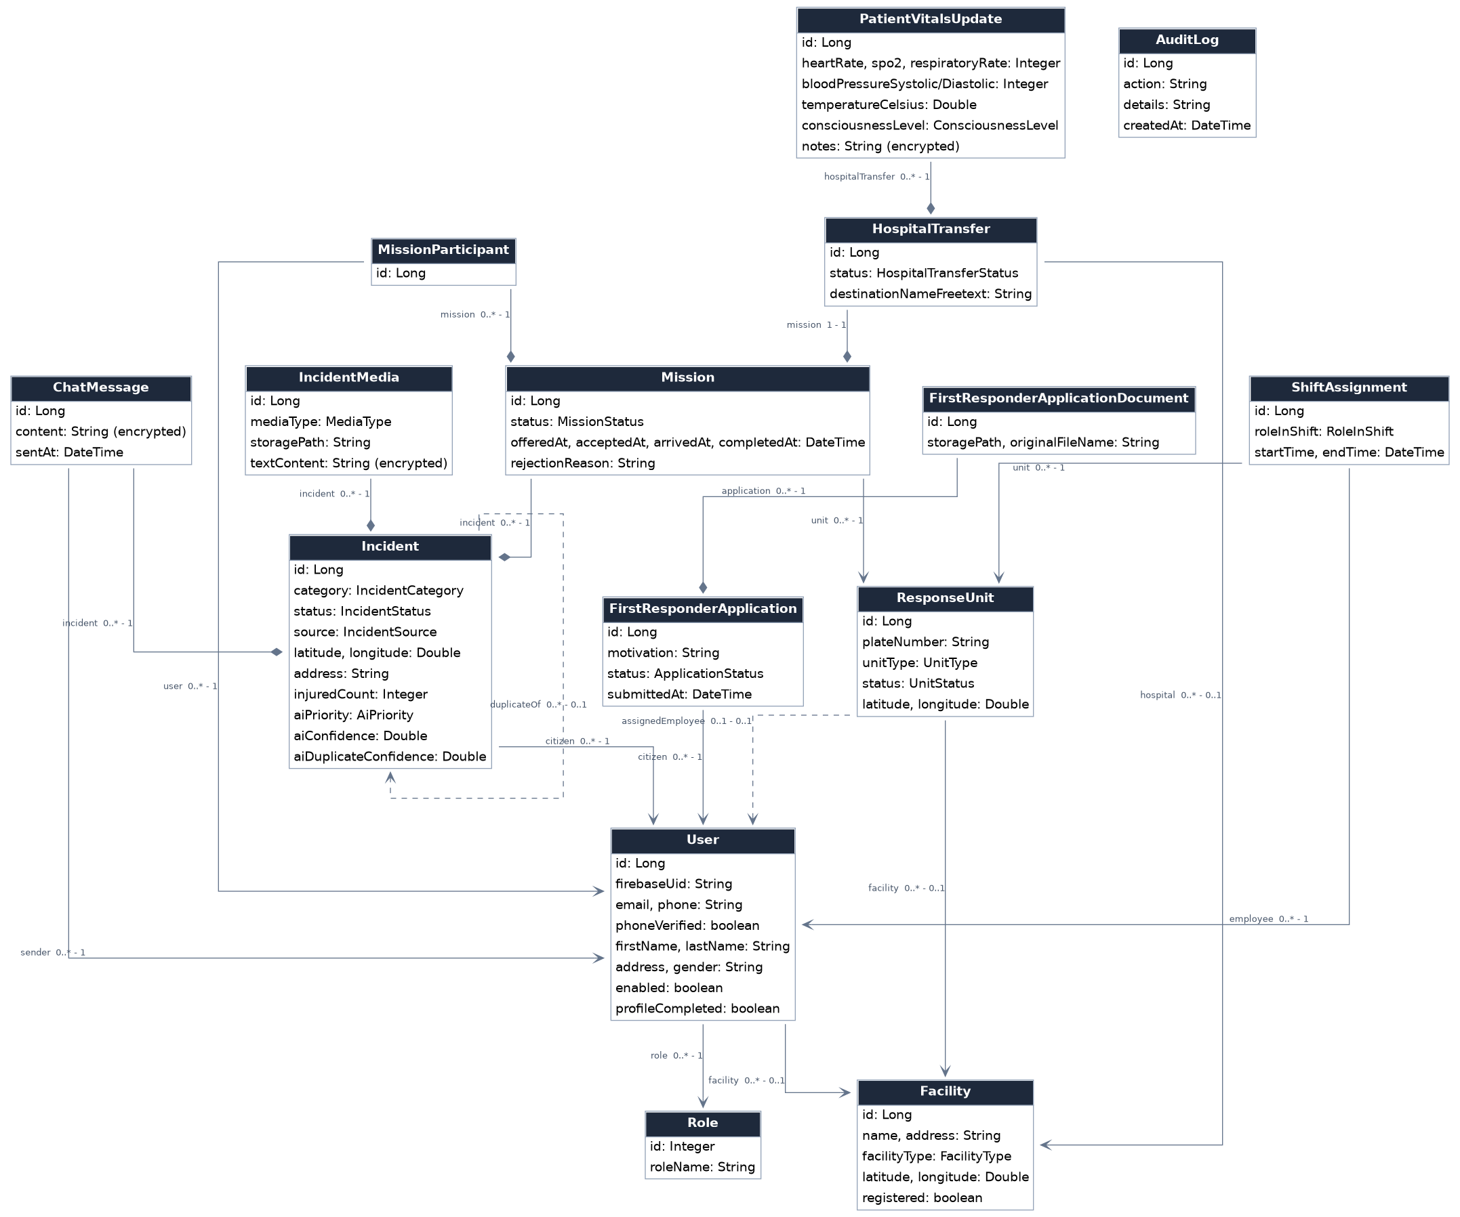
Figure 7.4 — Domain class diagram

Backend layering
The backend follows a strict controller → service → repository layering. Controllers translate HTTP to service calls and map exceptions to status codes; services hold all business rules and authorization; repositories are Spring Data JPA interfaces.
Area | Principal classes | Responsibility
Security | FirebaseTokenAuthFilter, SecurityConfig, WebSocketConfig | Verify tokens, resolve the user, open public endpoints, configure CORS and the WebSocket handshake
Identity | AuthServiceImpl, UserServiceImpl, ProfileCompletionEvaluator, FirebaseClaimsService, FirebaseSyncServiceImpl | Registration, profile rules, role claims, verified-only phone uniqueness, Firebase↔database reconciliation
Applications | FirstResponderApplicationServiceImpl | Atomic submission with documents, review, approval and personal unit creation
Incidents | IncidentServiceImpl, IncidentMediaServiceImpl, ChatServiceImpl | Submission, edit window, completion, duplicates, evidence, chat, access checks
Dispatch & field | MissionServiceImpl, ShiftServiceImpl, ResponseUnitServiceImpl | Assignment with row locking, mission lifecycle, shifts, unit status reconciliation, live location
Hospital | HospitalTransferServiceImpl, HospitalDashboardServiceImpl | Recommendation, selection, transfer progress, vitals, hospital view
Facilities | FacilityServiceImpl, FacilityDataSeeder, OverpassClient, RoleFacilityPolicy | Facility CRUD, OpenStreetMap seeding, role-to-facility-type policy
AI & geo | AiPriorityService, AiDuplicateDetectionService, ReverseGeocodingService | Asynchronous classification, duplicate suggestion, address resolution
Storage & crypto | SupabaseStorageService, ChatMessageContentConverter | Signed upload/download URLs; transparent AES-256-GCM field encryption
Real time | Incident-, Mission-, Chat-, Vitals-, and UnitEventPublisher | Publish state changes to STOMP topics

7.4 State Model
Three entities carry an explicit lifecycle. Each diagram shows the permitted transitions and the event that causes them.

Incident
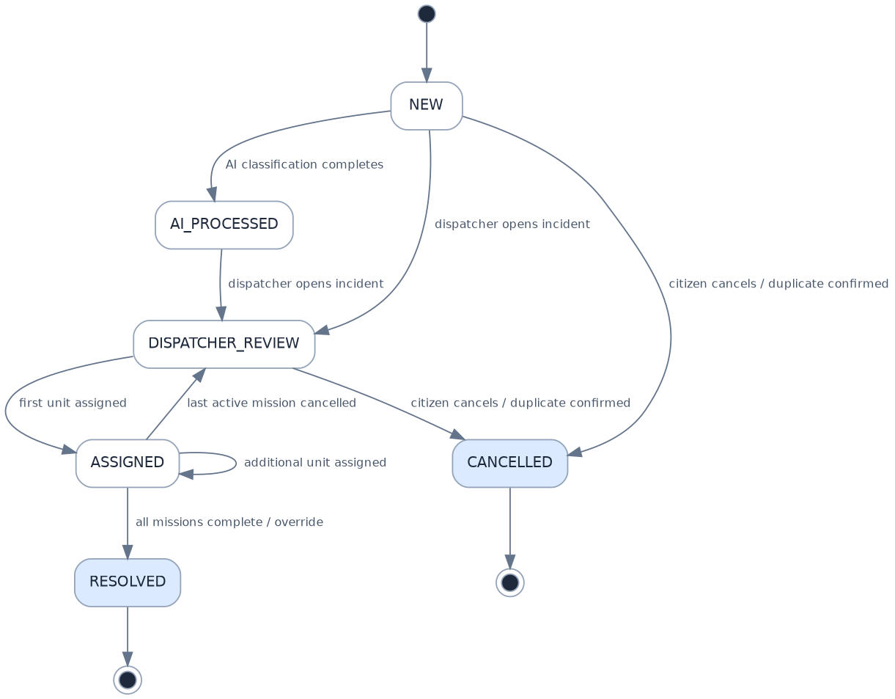
Figure 7.5 — Incident lifecycle
- A new incident is NEW; the AI result moves it to AI_PROCESSED, and a dispatcher opening it moves it to DISPATCHER_REVIEW (the AI step is not a prerequisite).
- The first unit assigned moves it to ASSIGNED; further units leave it there. Cancelling the last active mission returns it to DISPATCHER_REVIEW.
- RESOLVED is reached when every mission has completed, or by dispatcher override. CANCELLED is reached through a confirmed duplicate.
- IN_PROGRESS is part of the status enumeration but is reserved: no workflow currently enters it, because in-field progress is carried by the mission statuses.

Mission
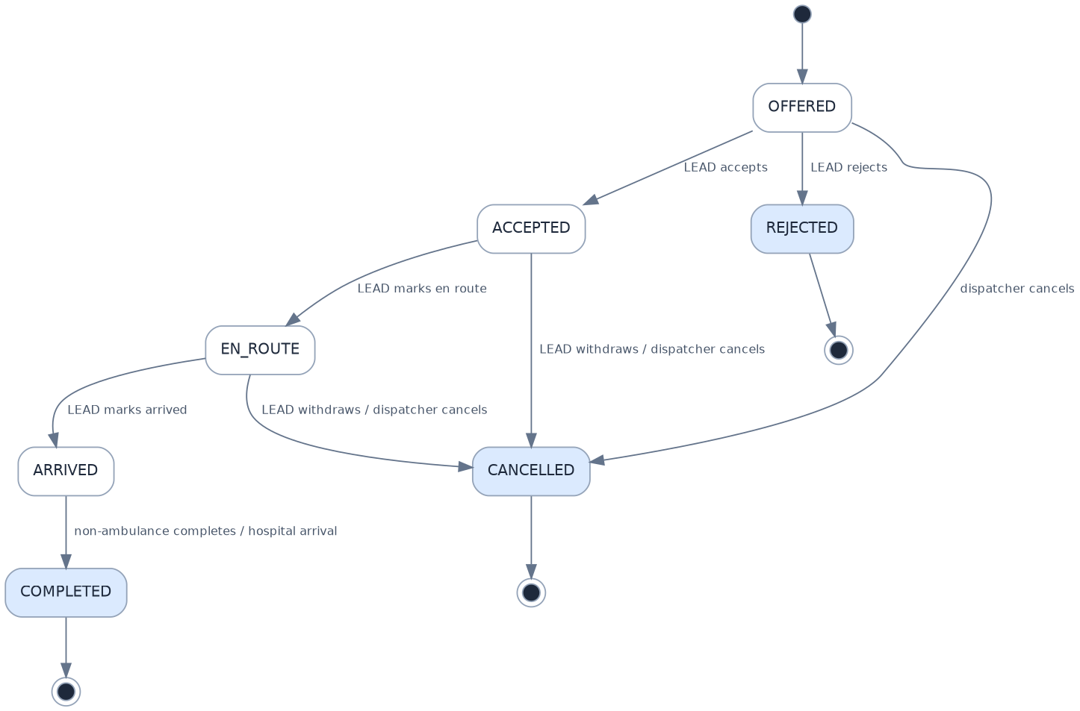
Figure 7.6 — Mission lifecycle
- Only the unit's LEAD accepts, rejects, progresses, withdraws, or completes. A dispatcher may cancel at any non-terminal stage.
- COMPLETED, REJECTED, and CANCELLED are terminal; each frees the unit.

Hospital transfer
Figure 7.7 — Hospital transfer lifecycle
Arrival at the hospital completes the parent mission and, when it was the last open one, resolves the incident.

7.5 Behavioral Views (Sequence Diagrams)

Incident submission, AI triage, and unit assignment
Submission returns as soon as the incident is stored. AI classification runs in the background and its result is pushed to dispatchers when ready. Assignment locks the unit row so that two dispatchers cannot offer the same unit.
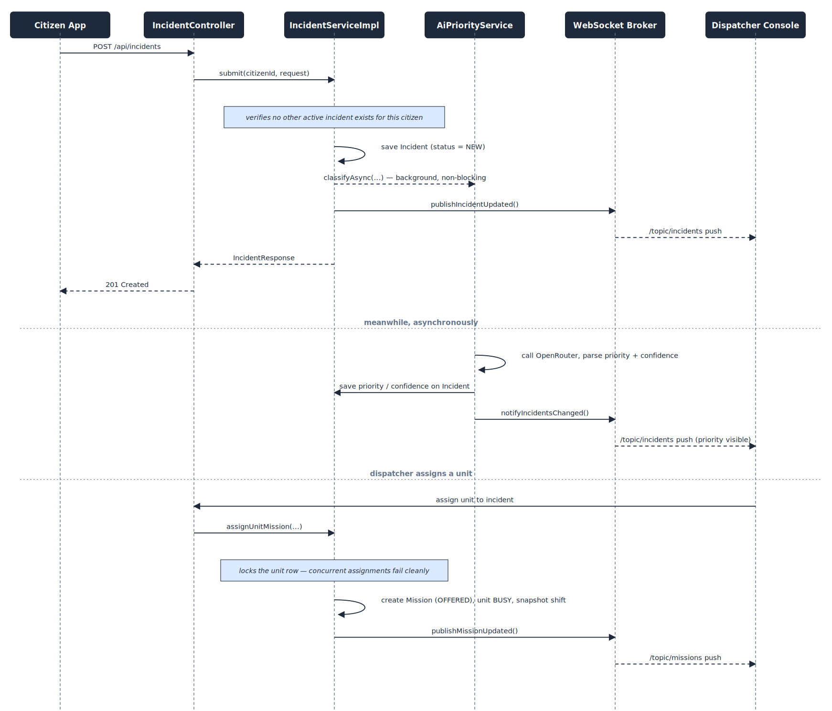
Figure 7.8 — Incident submission, AI triage, and assignment

Passwordless citizen registration
No account exists until the sign-in link is opened. The database record is created immediately after Firebase confirms the email; the profile gate then collects the remaining details and a password. Re-requesting a link for a half-registered account resumes at the profile step.
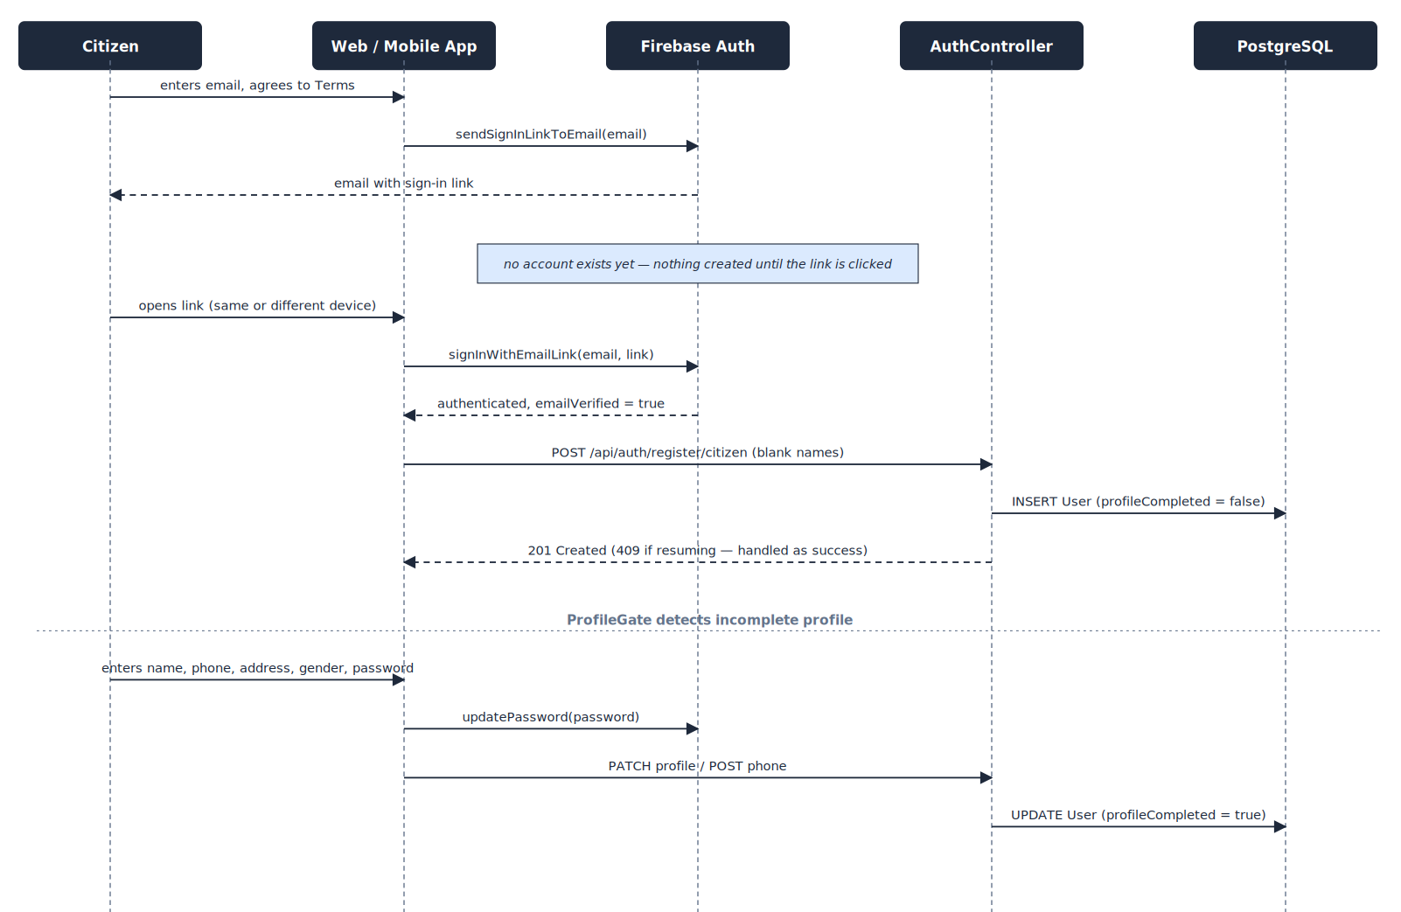
Figure 7.9 — Passwordless registration and profile completion

7.6 Authentication and Authorization Model

Token flow
- A user signs in with Firebase (email link, password, or Google) and receives an ID token.
- The web console additionally exchanges the token for an httpOnly session cookie used to gate page routes; the mobile app has no cookie and holds the token in memory.
- Every API call carries Authorization: Bearer <ID token>. A servlet filter verifies it with the Firebase Admin SDK, loads the NAJDA user (with role and facility), and exposes the role to Spring Security.
- Registration bootstrap, the email-availability check, the health endpoint, and the WebSocket handshake are the only endpoints reachable without a user record.

Authorization
Role checks are declared on controller methods and re-verified inside services, which also perform ownership checks (for example, that the caller is the unit's active LEAD, or took part in the incident being read).
Role | Console | Principal capabilities
Citizen | Emergency | Report and edit own incidents, chat, view own history, apply to become a First Responder
Dispatcher | Dispatch | Queue, assignment, cancellation, duplicates, completion override, retry AI, chat
Ambulance Crew · Police · Firefighter · First Responder | Responder | Shifts, missions, live location; ambulance additionally hospital handoff and vitals
Hospital Staff | Hospital | Incoming transfers and live vitals for the linked hospital
Admin | Admin | All dispatcher capabilities plus account, facility, unit, incident, and application administration
Super Admin | Admin | All admin capabilities plus Super Admin management, phone override, incident deletion, and Firebase reconciliation

External services
Service | Used for | If unavailable
Firebase Authentication | Sign-in, token verification, account administration, sign-in emails | Sign-in and registration are unavailable; existing sessions continue until token expiry
Supabase Storage | Private evidence and document storage via signed URLs | Uploads and viewing fail; incidents themselves are unaffected
OpenRouter (language model) | Priority classification and duplicate suggestion | Incident is stored without a priority; a dispatcher can retry
OSM Nominatim | Reverse geocoding | Address stays empty; coordinates remain authoritative; batch jobs stop on rate limiting
OSM Overpass | Facility seeding | Seeding fails over across mirrors, then reports an error
OSRM | Driving routes | Maps fall back to a straight line
EmailJS | Support form delivery | The form reports a failure and the user may retry

8 Business Rules
These rules govern system behaviour and are enforced on the server.
ID | Rule | Applies to
BR-1 | A citizen may have only one incident in an active status (NEW, AI_PROCESSED, DISPATCHER_REVIEW, ASSIGNED, IN_PROGRESS). | UC-6
BR-2 | An incident's coordinates must lie inside Egypt's bounding box. | UC-6
BR-3 | A citizen may edit an incident, or add or remove its evidence, only while it is NEW, AI_PROCESSED, or DISPATCHER_REVIEW. | UC-17
BR-4 | Evidence is uploaded to private storage through a signed URL and is registered only after the system confirms the file exists at that path; only permitted media types are accepted. | UC-6
BR-5 | Signed download URLs expire after five minutes and are issued only after an authorization check. | UC-5, UC-6, UC-18
BR-6 | AI output is advisory. A duplicate is suggested only for open incidents of the same category within 2 km and 120 minutes, at confidence 0.5 or higher. AI never assigns, cancels, or closes. | UC-13, UC-14
BR-7 | Only AVAILABLE units can be assigned, and a unit is available only while a LEAD is on shift for it. | UC-7, UC-10
BR-8 | Assignment locks the unit row; a unit is marked BUSY when a mission is offered and freed when the mission is rejected, cancelled, or completed. | UC-7, UC-8, UC-29
BR-9 | Mission actions and hospital-transfer actions may be performed only by the unit's active LEAD (dispatcher cancellation excepted). | UC-8, UC-9
BR-10 | When a mission is offered, the crew currently on shift is recorded as its participants. | UC-7
BR-11 | A LEAD may withdraw only while a mission is ACCEPTED or EN_ROUTE; a dispatcher may cancel at any non-terminal stage. Cancelling the last active mission reopens the incident. | UC-8, UC-29
BR-12 | A non-ambulance mission completes from ARRIVED; an ambulance mission completes when its hospital transfer arrives. An incident resolves when all its missions are complete; a dispatcher override completes them all. | UC-8, UC-9, UC-15
BR-13 | An employee may hold one active shift. Facility-linked roles may use only units at their own facility; Ambulance Crew and First Responder are exempt, and a First Responder works only their own unit. | UC-10
BR-14 | Hospital Staff must be linked to a hospital; Ambulance Crew may link to an ambulance station or hospital; Police to a police station; Firefighter to a fire station; other roles to none. | UC-2, UC-4
BR-15 | A facility's type is fixed after creation; its registered flag is set automatically when staff or a unit is linked. | UC-21
BR-16 | Recommended hospitals are those within 30 km of the incident, ranked by distance from the incident; the nearest is flagged. A free-text destination is allowed as a last resort. | UC-9
BR-17 | Vitals are accepted only while the transfer is en route and only for a registered hospital. | UC-9
BR-18 | A phone number is unique among verified numbers only. Unverified numbers may coexist; a verified number can never be claimed by another account. | UC-1, UC-30, UC-31
BR-19 | Citizen phone numbers are Egyptian mobile numbers (+20 followed by ten digits starting 10, 11, 12, or 15). | UC-1, UC-31
BR-20 | Passwords have at least eight characters with an uppercase letter, a lowercase letter, and a number. | UC-1, UC-31
BR-21 | Only a Super Admin may create or modify another Super Admin; the last enabled Super Admin cannot be disabled; phone overrides are Super Admin only and audit-logged. | UC-2, UC-3, UC-30
BR-22 | An application needs a verified email and phone, at least one document, and no other pending application; approval changes the role and creates the personal unit. | UC-5
BR-23 | Only the citizen, dispatchers, admins, and responders on an active mission may send chat messages; anyone who ever took part may read the history. | UC-18, UC-19
BR-24 | Chat content, incident free text, and vitals notes are encrypted at rest. | UC-6, UC-9, UC-19
BR-25 | Marking a duplicate cancels the incident and records the cancellation reason, actor, and time. | UC-14
BR-26 | A unit in use cannot be deleted. Reconciliation only returns BUSY units that have no active mission to AVAILABLE and never alters OFFLINE units. | UC-24, UC-25
BR-27 | Facility seeding skips unnamed records and duplicates by coordinates, and a rate-limit response from the geocoder stops the run. | UC-22, UC-23
BR-28 | Email changes take effect only after the confirmation link is opened. | UC-31

9 Testing Strategy

9.1 Approach
NAJDA is verified through scenario-based, end-to-end walkthroughs that exercise each use case with the role that performs it, supported by static guarantees built into the stack.
- Scenario verification per role. Each use case is walked through as the actor, including its alternate and exception flows, against a running stack.
- Schema validation at start-up. Hibernate validates entities against the Flyway-managed schema, so mapping drift fails the application on boot.
- Type safety. The web and mobile clients are strictly typed against the API contract, and both clients share the same contract types.
- Authorization checks. Each protected operation is exercised with a role that should be refused as well as one that should succeed.

9.2 Test Environment and Data
- A start-up initializer provisions one account per role, each backed by a test facility, so every console can be exercised immediately.
- Facilities are seeded from OpenStreetMap through the administration tools.
- Phone verification uses Firebase test phone numbers with fixed codes, so SMS delivery is not required.
- The full stack runs locally through Docker Compose, and the same build is deployed for staging checks.

9.3 Verification Scenarios
ID | Scenario | Expected result | Use case
TC-1 | Register with an email link, open it on the same browser | Account created with verified email; profile completion shown | UC-1
TC-2 | Open the sign-in link on a different device | Email is requested once, then registration continues | UC-1
TC-3 | Abandon registration, request a new link | Registration resumes at profile completion without error | UC-1
TC-4 | Admin creates an employee with a facility-linked role | Account created, facility registered, reset link returned | UC-2
TC-5 | Plain Admin tries to create or edit a Super Admin | Refused with access denied | UC-2, UC-3
TC-6 | Citizen with unverified phone submits an application | Refused with a verification message | UC-5
TC-7 | Approve an application | Role becomes First Responder; personal unit exists | UC-5
TC-8 | Submit an incident with GPS and evidence | Incident NEW; dispatcher sees it live; address and AI priority appear later | UC-6
TC-9 | Submit a second incident while one is active | Refused with a conflict | UC-6
TC-10 | Edit description after a unit is assigned | Refused; before assignment it succeeds | UC-17
TC-11 | Open a closed incident as a past responder | History, evidence, and chat are readable | UC-18
TC-12 | Send a chat message as a non-participant | Refused | UC-19
TC-13 | Two dispatchers assign the same unit | One succeeds; the other receives a conflict | UC-7
TC-14 | Cancel an accepted mission | Unit AVAILABLE; incident back to review if no other mission | UC-29
TC-15 | Retry AI after a failed classification | Priority populates and is pushed live | UC-13
TC-16 | Confirm and dismiss an AI duplicate | Confirm cancels and links; dismiss clears the suggestion | UC-14
TC-17 | Force-complete an incident with two active units | Incident RESOLVED; both units AVAILABLE | UC-15
TC-18 | Super Admin deletes an incident with a busy unit | Incident removed; unit freed | UC-16
TC-19 | Start, join, leave, and end a shift | Statuses follow the rules; ineligible attempts are refused | UC-10
TC-20 | A CREW member tries to accept a mission | Refused; only the LEAD may act | UC-8
TC-21 | LEAD withdraws while en route | Mission CANCELLED; unit freed | UC-8
TC-22 | Share location with permission denied | Status shows denied; dispatch uses the facility location | UC-12
TC-23 | Select a hospital on the map and confirm | Transfer SELECTED; recommended and own-base indicators visible | UC-9
TC-24 | Submit vitals for an unregistered hospital | Refused with an explanation | UC-9
TC-25 | Hospital staff opens an incoming transfer | Map and live vitals update as readings arrive | UC-20
TC-26 | Seed hospitals twice | Second run creates no duplicates | UC-22
TC-27 | Geocoder rate-limits during seeding | Run stops cleanly; re-run later completes | UC-22, UC-23
TC-28 | Create an ambulance unit | Only ambulance stations and hospitals are offered as home station | UC-24
TC-29 | Run Firebase reconciliation | Orphans listed; sync creates an incomplete profile; deletes are guarded | UC-26
TC-30 | Switch to Arabic | Layout flips to right-to-left; numbers and links stay left-to-right | UC-28

10 Requirements Traceability Matrix
Every functional requirement traces forward to a user story, a use case, and the component that implements it.
Req. | User story | Use case | Implementing component
FR-1 | US-1 | UC-1 | AuthController.registerCitizen · AuthServiceImpl.registerCitizen
FR-2 | US-2 | UC-1 | UserServiceImpl.updateProfile / setUnverifiedPhone · ProfileCompletionEvaluator
FR-3 | US-1 | UC-1 | AuthServiceImpl.registerCitizen (existing UID → conflict handled by client)
FR-4 | US-3 | UC-1 | AuthController email-availability endpoint · useEmailAvailability
FR-5 | — | All | FirebaseTokenAuthFilter · SecurityConfig
FR-6 | US-4 | UC-2 | AuthController.registerEmployee · AuthServiceImpl.registerEmployee
FR-7 | US-4 | UC-2, UC-4 | RoleFacilityPolicy · FacilityServiceImpl.requireFacilityOfType
FR-8 | US-5 | UC-30 | UserController · UserServiceImpl.getAllUsers
FR-9 | US-5 | UC-3 | UserServiceImpl.disableUser / enableUser
FR-10 | US-5 | UC-4 | UserServiceImpl · FirebaseClaimsService.syncRoleClaim
FR-11 | US-6 | UC-30 | UserServiceImpl.adminOverrideEmail / adminOverridePhone · AuditLog
FR-12 | US-5 | UC-30 | UserServiceImpl.resendPasswordReset
FR-13 | US-6 | UC-1, UC-30, UC-31 | UserServiceImpl.setUnverifiedPhone / syncVerifiedPhone / adminOverridePhone
FR-14 | US-7 | UC-31 | UserServiceImpl · Firebase client SDK (email, phone, password)
FR-15 | — | All | @PreAuthorize on controllers · service-layer ownership checks
FR-16 | US-8 | UC-5 | FirstResponderApplicationServiceImpl.submit
FR-17 | US-9 | UC-5 | FirstResponderApplicationServiceImpl.approve / reject / deleteDocument
FR-18 | US-6 | UC-26 | FirebaseSyncServiceImpl · FirebaseSyncController
FR-19 | US-10 | UC-6 | IncidentController · IncidentServiceImpl.submit
FR-20 | US-10 | UC-6 | IncidentServiceImpl.submit (active-incident check)
FR-21 | US-11 | UC-6 | IncidentMediaServiceImpl · SupabaseStorageService
FR-22 | US-12 | UC-17 | IncidentServiceImpl.updateInjuredCount · IncidentMediaServiceImpl
FR-23 | US-13 | UC-18 | IncidentServiceImpl (mine, getById, requireCanView)
FR-24 | US-15 | UC-18 | IncidentMediaServiceImpl.getDownloadUrl
FR-25 | — | UC-6 | ReverseGeocodingService
FR-26 | US-14 | UC-19 | ChatController · ChatServiceImpl
FR-27 | US-15 | UC-19 | ChatMessageContentConverter (chat, incident text, vitals notes)
FR-28 | US-16 | UC-7 | IncidentServiceImpl queue / active · IncidentEventPublisher
FR-29 | US-17 | UC-7 | MissionServiceImpl.assignUnitMission · web unit-assignment selection
FR-30 | US-18 | UC-7 | MissionServiceImpl (pessimistic unit lock)
FR-31 | US-19 | UC-29 | MissionServiceImpl.cancelMission
FR-32 | US-19 | UC-15 | IncidentServiceImpl.completeIncident
FR-33 | US-21 | UC-16 | IncidentServiceImpl.deleteIncident
FR-34 | US-17 | UC-7 | Live operations map (web) · OSRM routing
FR-35 | US-20 | UC-14 | IncidentServiceImpl.markDuplicate / dismissDuplicateSuggestion
FR-36 | US-32 | UC-13 | IncidentServiceImpl.retryAiPriority
FR-37 | US-22 | UC-10 | ShiftServiceImpl · ShiftController
FR-38 | US-22 | UC-10 | ResponseUnitServiceImpl.getUnitsForFacility
FR-39 | US-23 | UC-8 | MissionServiceImpl.acceptMission / rejectMission
FR-40 | US-24 | UC-8 | MissionServiceImpl (en route, arrived, complete, withdraw)
FR-41 | US-25 | UC-12 | ResponseUnitServiceImpl.updateLocation · location-sharing hook
FR-42 | US-26 | UC-11, UC-25 | ShiftServiceImpl (force end) · ResponseUnitServiceImpl.reconcileStatuses
FR-43 | US-25 | UC-8 | Mission detail and past-missions views
FR-44 | US-27 | UC-9 | HospitalTransferServiceImpl.getRecommendedHospitals
FR-45 | US-27 | UC-9 | Hospital selection map and transfer panel
FR-46 | US-30 | UC-9 | HospitalTransferServiceImpl (selection and progression)
FR-47 | US-28 | UC-9 | HospitalTransferServiceImpl.sendVitalsUpdate · VitalsEventPublisher
FR-48 | US-29 | UC-20 | HospitalDashboardServiceImpl · hospital feed
FR-49 | US-16 | UC-13 | AiPriorityService
FR-50 | US-31 | UC-14 | AiDuplicateDetectionService
FR-51 | US-31 | UC-13, UC-14 | AI services write advisory fields only
FR-52 | US-33 | UC-21 | FacilityServiceImpl · FacilityController
FR-53 | US-33 | UC-22 | FacilityDataSeeder · OverpassClient
FR-54 | US-33 | UC-23 | FacilityServiceImpl.backfillMissingAddresses
FR-55 | US-34 | UC-24 | ResponseUnitServiceImpl · unit form
FR-56 | US-35 | UC-14, UC-15 | Admin incidents feed and detail panel
FR-57 | US-36 | UC-28 | next-intl · react-i18next · language switchers
FR-58 | US-37 | UC-27 | Support page (EmailJS)
FR-59 | US-38 | UC-1, UC-6, UC-8, UC-10 | Expo mobile application

11 Assumptions and Constraints

11.1 Assumptions
ID | Assumption
A-1 | NAJDA operates in Egypt: phone numbers use +20, incident coordinates are validated to Egypt's bounding box, and facility data is drawn from Egyptian OpenStreetMap records.
A-2 | Citizens can supply a location, by device GPS or by placing a pin on the map.
A-3 | Users have connectivity sufficient for live updates; the interface remains usable without them but refreshes less promptly.
A-4 | More than one environment (for example local development and a hosted instance) may share one Firebase project, which is why account reconciliation tooling exists.
A-5 | The platform is a simulation: no report dispatches a real unit and nothing is connected to a real emergency service.

11.2 Constraints
ID | Constraint
C-1 | Free public services (Nominatim, Overpass, the public OSRM server, OpenFreeMap, free language models) impose usage limits and variable availability. The platform degrades gracefully around each, and geocoding batches are paced to a one-request-per-second policy.
C-2 | Live updates use an in-memory STOMP broker inside a single API instance; running several instances would require a shared broker.
C-3 | A hosted free-tier API may be idle between uses, so the first request after a quiet period can be slow.
C-4 | Email uniqueness within the password and email-link providers is enforced by Firebase and cannot be relaxed; the registration flow is designed around that.
C-5 | On mobile, phone verification supports Firebase test numbers, and the mobile client covers the Citizen and Responder roles; use cases marked Web are available on the web console.
C-6 | The mobile application is distributed as a signed Android package through GitHub Releases.

12 Design Decisions and Future Work

12.1 Key Design Decisions
Decision | Rationale
Firebase is identity only; Postgres owns authority | A managed provider handles credentials and verification, while roles, facility links, and history live in one database that every permission check can trust.
Create the account record only after email confirmation (passwordless link) | Firebase refuses a second password account for an address, so an abandoned unverified sign-up could lock out the real owner. Deferring creation until the link is opened removes the problem entirely.
WebSocket push over an in-memory broker | Meets the live-update requirement with no extra infrastructure for a single-instance deployment; a shared broker is a contained change if scale ever requires it.
One Facility entity with a type | Hospitals and stations share location, address, and registration semantics; one table removes parallel code paths.
A shift is the only evidence a unit has an operator | Assignment is gated on a LEAD being on duty, so dispatch never offers work to an unattended vehicle.
Phone uniqueness only among verified numbers, in the application | A blanket constraint lets an unverified entry block the real owner. Enforcing at verification time protects owners while allowing unverified overlap.
Private storage with short-lived signed URLs | Media is sensitive; no link outlives its purpose, and every view is an authorization decision.
Server-held field encryption, not end-to-end | Dispatchers and administrators must be able to read conversations for oversight, so protection targets database exposure rather than the application itself.
Hospital recommendation measured from the incident | The incident location always exists and does not move, unlike a unit's possibly stale GPS fix.
Locale in a cookie, not the URL | NAJDA is an authenticated tool, so per-language URLs for search indexing add cost without benefit.
Versioned migrations with schema validation | Two environments share one schema; numbered migrations apply identically to both and validation fails loudly on drift.
AI is advisory | Priority and duplicate output inform a human decision and are always dismissible.

12.2 Future Work

Wearable and sensor integration
The data model is already prepared for incidents that originate from a device rather than a person: each incident carries a source (currently CITIZEN_APP, with SENSOR_DEVICE reserved). The planned extension lets a citizen pair a wearable, such as a smartwatch, with their account. When the device detects a health event — for example a fall or an irregular heart rhythm — it reports to the backend, which would either attach the reading to the citizen's current incident or open a medical incident of its own, then run it through the same triage and dispatch flow.
- Pairing and authentication. A citizen pairs a device from their account and receives a long-lived, revocable device key, since a wearable cannot perform an interactive sign-in.
- Structured readings. Device reports carry an event type, measurements such as heart rate, and a location, stored as structured records linked to the incident rather than flattened into text.
- Active-incident handling. A report from a citizen who already has an active incident updates that incident as an urgent change instead of creating a competing one.

Appendix A Technology Stack
Layer | Technology | Purpose
Backend | Java, Spring Boot | REST API, STOMP WebSocket, application services
 | Spring Security, Spring Data JPA / Hibernate | Authentication filter, method-level authorization, persistence
 | PostgreSQL, Flyway | System of record and versioned schema migrations
 | Firebase Admin SDK | Token verification, account and claim management
 | Docker, Docker Compose | Container image and one-command local stack
Web console | Next.js (App Router), React, TypeScript | Role-scoped console for every role
 | Tailwind CSS v4 | Styling, dark mode, logical (RTL-aware) utilities
 | TanStack Query, Zustand | Server state and local state
 | next-intl | English / Arabic with right-to-left layout
 | MapLibre GL, @stomp/stompjs | Maps and live updates
 | Firebase JS SDK, EmailJS | Sign-in; support form delivery
Mobile app | Expo SDK 57, Expo Router, React Native, TypeScript | Citizen and Responder companion app
 | NativeWind v4, react-i18next | Styling; English / Arabic with RTL
 | expo-location, react-native-webview + MapLibre GL JS | Location tracking; live maps
External services | Firebase Authentication | Identity
 | Supabase Storage | Private media bucket with signed URLs
 | OpenRouter | Language-model access for triage
 | OpenStreetMap: Overpass, Nominatim; OSRM; OpenFreeMap | Facilities, geocoding, routing, map tiles
Hosting | Vercel (web), Render (API) | Hosted deployment

Appendix B API Reference
The API is REST over JSON under /api, with a STOMP endpoint at /ws. Errors return a JSON body { "error": "…" } with status 400 (invalid input), 401 (unauthenticated), 403 (not permitted), 404 (not found), or 409 (conflict with current state). Authentication is Authorization: Bearer <Firebase ID token>.
Base path | Operations | Access
/api/auth | Register citizen (bootstrap after sign-in); register employee; current user; email availability | Bootstrap and availability public; employee creation Admin; current user any user
/api/users | Search and paginate; update profile; change role; enable / disable; link facility; override email; override phone; sync verified phone / email; generate reset link | Self for own profile; Admin for administration; Super Admin for phone override
/api/facilities | List (optionally by type); create; update; address backfill | Read: authenticated · Write: Admin
/api/admin/facilities | Seed facilities by type from OpenStreetMap | Admin
/api/units | List; units for my facility; create; update; delete; report location; reconcile statuses | Admin for management; LEAD for location
/api/shifts | Start; join; leave; end; current shift; force-end a unit's shift | Responder; force-end Admin
/api/incidents | Submit; mine; queue; active; all; by id; edit injured count; retry AI priority; mark duplicate; dismiss duplicate suggestion; complete; delete | Citizen for own; Dispatcher / Admin for operations; delete Super Admin
/api/incident-media | Create signed upload URL; register evidence; signed download URL; edit text; delete | Citizen for own incident; participants for viewing; Admin override on delete
/api/incidents/{id}/chat | List messages; send message | Participants (send restricted to active participants)
/api/missions | Assign unit; mine; by incident; accept; reject; en route; arrived; complete; withdraw; cancel | Dispatcher for assign / cancel; unit LEAD for the rest
/api/hospital-transfers | Recommended hospitals; select destination; mark en route / arrived; submit vitals; transfer by mission; transfers by hospital | Ambulance LEAD; hospital staff for their hospital
/api/hospital-dashboard | Incoming transfers for the caller's hospital | Hospital Staff
/api/first-responder-applications | Submit (multipart with documents); mine; all; approve; reject; document download URL; delete document | Citizen for own; Admin for review
/api/admin/firebase-sync | Report; create profile from Firebase account; delete orphaned Firebase account; delete orphaned database user | Super Admin
/ws | STOMP endpoint with topic subscriptions (Section 7.1) | Handshake public; topics carry non-sensitive change notices
/actuator/health | Health probe | Public

Appendix C Glossary
Term | Definition
Incident | The central record of an emergency, from report to closure.
Mission | One response unit's assignment to one incident, with its own lifecycle.
Response unit | A vehicle — or a First Responder's personal unit — that can be assigned to incidents.
Shift | The period during which an employee is on duty for a unit, as LEAD or CREW.
LEAD / CREW | The accountable operator of a unit's shift, and a crew member riding along.
Facility | A hospital, ambulance station, fire station, or police station.
Registered facility | A facility with real staff or units linked to it.
Hospital transfer | The destination and progress of an ambulance's patient handoff.
Vitals | Patient measurements (heart rate, blood pressure, SpO2, respiratory rate, temperature, consciousness) transmitted during a transfer.
Triage | Ranking an incident's urgency; here assisted by a language model and always reviewed by a person.
Passwordless link | A one-time sign-in link emailed to the user that confirms they control the address.
Profile gate | The application check that holds a user at profile completion until their account is complete.
Signed URL | A time-limited link, issued after an authorization check, that grants access to one stored file.
Orphaned account | An account that exists in Firebase or in the database but not in the other.
Migration | A numbered, versioned database change applied identically in every environment.

